Sprint 1 Report

Cocoa Pod Borer (CPB) Egg Identification with AI

Portfolio task 2/3/4

Unit code: COS40005/EAT40005

Unit Name: Computing/ Engineering Technology Project A

Submission date: 10th October 2025

# **Acknowledgment of Country**

All the members are from Malaysia

**Methodology**

# **Technology Stack**

**Frontend Development**

* **Framework: Flutter 3.19+ (Dart 3.3+)**
* **Key Dependencies:**
  + **tflite_flutter: TensorFlow Lite inference with GPU delegate**
  + **firebase_core: Firebase initialization**
  + **firebase_auth: Email/password + 2FA authentication**
  + **cloud_firestore: Real-time database with offline persistence**
  + **firebase_storage: Image upload/download with resume capability**
  + **google_sign_in: 2FA with Google Authenticator integration**

**Backend Services - Firebase (Blaze Plan)**

**Firebase Pricing Estimate - Blaze Plan (Pay-as-you-go)**

|  |  |  |  |
| --- | --- | --- | --- |
| **Service** | **Free Quota** | **Beyond Free Quota** | **Monthly Cost (1,000 users)** |
| **Authentication** | **50,000 Monthly Active Users** | **$0.0055 per additional user** | **$0.00 (within free tier)** |
| **Cloud Firestore** | **1 GiB storage, 50k reads/day** | **Storage: $0.18/GiB**  **Reads: $0.06/100k**  **Writes: $0.18/100k** | **~$12.50 (300k scans/month)** |
| **Cloud Storage** | **1 GiB storage, 10k downloads** | **Storage: $0.026/GiB**  **Downloads: $0.12/GiB** | **~$45.00 (1,500 GiB storage + downloads)** |

**Total Estimated Monthly Cost: ~$57.50 for 1,000 active farmers**

**AI/ML Development - Specific Implementation**

* **Model Training Environment: Google Colab**
* **CPB Object Detection Model: YOLOv8n**
* **Image Classification Model: MobileNetV2**
* **Training Framework: Ultralytics YOLOv8 + TensorFlow 2.15+**
* **Mobile Deployment: TensorFlow Lite**
* **Data Pipeline: Roboflow for annotation & augmentation**
* **Target Performance: at least 70%**

**Development & Deployment Tools**

* **IDE:** Visual Studio Code with Flutter/Dart extensions
* **Version Control:** Git/GitHub, Vercel
* **Project Management:** Trello
* **Communication:** Microsoft Teams, WhatsApp, Google Meet
* **Documentation:** Google Drive, Microsoft Office
* **Production Deployment:** Google Play Store (Android only for MVP)

# **Software Requirements Specification (SRS) Version 1**

**1. Introduction**

**1.1 Purpose**

This Software Requirements Specification (SRS) Version 1 document provides a detailed description of the requirements for enhancing the existing DMCOCOA mobile application with an AI-Powered Cocoa Pod Borer (CPB) Egg Detection Module and introducing a new role in the system which will be admin, accompanied with a new web-based administration and data management portal. The primary goal of this project is to solve the fundamental user difficulty in identifying microscopic CPB eggs (less than 0.5 mm) by automating the detection process through computer vision and create both user-centric mobile application used by cocoa farmers and web portal for administration and management of data collected. This document is intended for the development team, testers, project stakeholders at Lembaga Koko Malaysia (MCB), liaisons, and academic supervisors. It will serve as the definitive reference for the system's capabilities, behaviour, and constraints throughout the design, implementation, testing, and validation phases. This SRS is the first draft made up till this point, further changes will be made throughout the project period.

**1.2 Scope**

This project focuses on the research, development, and integration of a core AI subsystem into the client's existing DMCOCOA ecosystem. The current DMCOCOA application already provides a decision-making framework for pesticide spraying based on the Economic Threshold Level (ETL) and a database for both CPB pest management and cocoa yield records. However, the critical step of CPB egg counting is currently performed manually by farmers using a portable microscope, a process identified by the client as difficult and prone to error due to the eggs' tiny size.

The scope of this project is to replace this manual counting step with an automated, AI-driven solution.

**The project will deliver three main components:**

1. **AI-Powered CPB Egg Detection Module:** This is the main objective of the project. It comprises of:
   1. An Image Quality Assessment Model to ensure captured images are suitable for analysis, in other words high-resolution and images taken up close to detect the existence of CPB eggs.
   2. A CPB Egg Detection & Counting Model (using a fine-tuned pre-trained object detection architecture like YOLO) that can identify and count eggs from a pod image.
   3. Integration Code to package these models for use within a mobile application (e.g., TensorFlow Lite).
2. **Enhanced DMCOCOA Mobile Application:** A proof-of-concept mobile application that demonstrates the integrated AI module. This app will:
   1. Allow users to capture images of cocoa pods directly via the phone's camera. Process the image locally on the device using the AI module to count CPB eggs. Then, automatically feed the egg count into the existing ETL-based AI decision logic to generate a spraying recommendation (TREAT, Continue Collecting Samples). This provides a seamless user experience that mirrors the workflow of the existing app but with automated egg counting.
   2. Allow cocoa farmers to add more than one farm they are overseeing, either at registration, or at the home page. The existing system only allows one farm entry which the client has pointed out would be an issue as some farmers work on several farms.
   3. Integration of Google Maps in the home page where farm selection is done. Farmers are required to pin their farm’s location to ease management.
   4. Upgrade the security of the DMCOCOA app where user verification is required after registration and when trying to sign in the app. This is facilitated through email and WhatsApp OTP.
3. **Web-based Administration and Data Management Portal:** 
   1. Only authorised users called admin, are allowed to use the portal with valid credentials. Here, they can management users who registered for an account on the DMCOCOA mobile app then decide to approve verified farmers or reject registrars who could not prove their identity.
   2. Admin can view all records from the mobile app side like CPB pest monitoring and cocoa yield management.
   3. Economic Injury Level could also be manipulated on this side as it is determined by the statistics department of MCB to set it and in which affects the decision logic if those changes.
   4. Viewing records from specific farms with filtering options by state or district.

**2. Project Overview**

**2.1 Project Context**

The system integrates with:

* Existing DMCOCOA EIL decision logic
* Firebase backend services (Auth, Firestore, Storage)
* Google Authenticator for 2FA
* Mobile device camera and storage
* Web browsers for admin portal access

**2.2 Domain Vocabulary**

* CPB: Cocoa Pod Borer (*Conopomorpha cramerella*)
* MCB: Lembaga Koko Malaysia (Malaysian Cocoa Board)
* EIL: Economic Injury Level
* ETL: Economic Threshold Level
* mAP: mean Average Precision
* YOLO: You Only Look Once (object detection system)
* TFLite: TensorFlow Lite
* OTP: One-time Password
* TOTP: Time-based One-time Password

**2.3 Goals and Objectives**

**2.3.1 Goals**

Our main goal is to develop a user-friendly mobile application that enables farmers to effectively monitor and manage Cocoa Pod Borer (CPB) pest populations and record cocoa yield data through an integrated, AI-powered decision support system. The app aims to simplify data collection, improve pest control timing, and support sustainable cocoa production through accurate, data-driven recommendations.

**2.3.2 Objectives**

**Simplify Pest Monitoring:**

As one of our objectives is to ensure the main users which are farmer can be able to use our mobile app. Hence, we make it easy to navigate which is tailored to the needs of cocoa farmers regardless of technical experience or language preference.

**Enhance CPB Pest Management:**  
Implement an AI-driven detection feature that identifies and counts CPB eggs from cocoa pod, helping farmers determine whether to apply pesticide based on the Economic Injury Level (EIL).

**Facilitate Yield Tracking:**  
Help improve the module for farmers to record, manage and analyse their cocoa yield data, to increase productivity monitoring and financial planning.

**2.4 System Actors**

|  |  |
| --- | --- |
| Actors | Description |
| Cocoa Farmer | **Farmers who will be using the revised DMCOCOA mobile application for CPB pest monitoring, cocoa yield management after farm selection.** |
| Admin | **Authorized staff in Lembaga Koko Malaysia who can manage the DMCOCOA mobile application users, view all record history from both CPB pest monitoring and cocoa yield management, manipulate EIL value, and view farm details and location.** |
| AI Detection Module | **Processes images, performs quality checks, and returns detection results, here being a number of CPB eggs.** |
| Google Authenticator | **External system actor that provides Time-based OTP (TOTP) for 2FA verification at sign in and register.** |
| Firebase Services | **External system actor that provides backend services for database, storage, authentication, and hosting.** |

**2.5 Constraints**

* AI model must achieve minimum mAP of 0.70
* Must comply with Malaysia’s PDPA (Personal Data Protection Act) standards.
* Mobile app must function offline for core detection tasks
* Verification method other than email and WhatsApp TOTP in the case that cocoa farmers who are at rural areas could not get stable internet connection.

**2.6 Assumptions and Dependencies**

* MCB will provide adequate annotated training data
* Client will validate EIL formulas
* Firebase services will remain available and functional
* AI model performance will meet minimum accuracy requirements
* Cocoa farmers should have a stable internet connection when registering and signing in the mobile application.

**3. Specific Requirements for DMCOCOA Mobile Application**

**3.1 Functional Requirements**

**User Module**

**1. User Registration**

* Cocoa farmers will start with registering for an account with
  + - Personal Details:
      * + Username
        + Phone Number
        + Email
    - Farm Details:
      * + State
        + District
        + Village (Optional)
        + Postcode (Optional)
        + Farm Area in hectares
        + Number of cocoa trees stands in the farm

**2. User Sign in**

* Cocoa farmers sign in their accounts after admin approval after getting a message through email or WhatsApp indicating that their accounts are activated.
* When signing in, email or phone number is needed to receive a TOTP, then users are prompted to create a new password.
* After the first sign in, users are allowed to stay signed in.
* In the case of user logging out, only then a sign in is needed with TOTP 2FA.

**3. User Sign Out**

Cocoa farmers can sign out of their account.

**4. User Forget Password**

* **Cocoa farmers who forget their password are allowed unlimited attempts to sign in as not to further complicate things as per client’s request.**
* **Cocoa farmers can request to change password.**

**5. User Resets Password**

* **After creating a new password, user will be sent a TOTP for verification before successfully signing in their account.**

**6. View User Profile**

* **Profile of user can be seen and edited.**

**Farm Selection Module**

**7. Cocoa farmers can add new farm with location (Google Maps), state, district, village (optional), postcode (optional), farm area in hectares, number of cocoa trees stands.**

**8. Cocoa farmers can view farms that were added, a snippet of google maps with pinpoint that can be tapped in, farm area in hectares, number of cocoa trees stands and pesticide spraying decision (TREAT or Continue taking samples) in each farm tab in the home page.**

**9. Farmer can select farm to manage.**

**CPB Pest Monitoring Module**

**10. When adding a record, farmers are first prompted to fill up pesticide cost information. (Pesticide Brand, Pesticide Cost, Pesticide Price per Litre, Amount of pesticide in spray pump mixture per litre)**

**11. Farmers are required to fill up Economic Injury Level (EIL) page. (Daily labour cost, Farm Area Sprayed per day per hectare, wet cocoa beans price per kg, frequency of pesticide** **use per year, wet cocoa beans productivity per hectare(kg))**

**12. CPB egg sampling page with camera and AI integration.**

**13. Decision on Monitoring CPB Eggs (TREAT/ Continue taking sample).**

* **When the decision is “TREAT”, cocoa farmer is only expected to return to this page after 10 days to collect the next sample.**
* **When the decision is “Continue Taking Sample”, cocoa farmers are allowed to keep entering samples until the limit is reached, which is 10 samples per record.**

**14. Record of Last CPB Pest Monitoring will show the date, decision (TREAT/ Continue Taking Sample) and remarks (Reuse DMCOCOA on “date” or “Collect next sample when needed”)**

**15. A “TREATED” button will be added next to the decision value (TREAT/ Continue Taking Sample) for farmers to confirm they have sprayed pesticides. (Problem: When does 10-day countdown start, after pressing button or right after getting “TREAT” decision)**

**Cocoa Yield Management Module**

**16. Farmers are to input cocoa yield information (cocoa beans type, grade, cocoa bean weight sold, sales income, remarks)**

**Record History Module**

**17. Filtering by ‘start date’ and ‘end date’.**

**18. CPB Pest Monitoring record history**

**19. Cocoa Yield record history**

**3.3 Non-Functional Requirements**

**Performance**

* **The AI Detection process must complete within 10 seconds per image**
* **The system should be handle at least 100 concurrent users without noticeable performance degradation**
* **Local (offline) inference will maintain consistent speed regardless of internet connection quality.**
* **Interface shall support Bahasa Melayu and English**

**Accuracy**

* **The AI model must achieve at least 70% detection accuracy (mAP ≥ 0.70) for identifying Cocoa Pod Borer (CPB) eggs.**
* **The image quality validation model must correctly classify acceptable images with ≥70% accuracy.**
* **False positives and false negatives should not exceed 10% of total detections.**

**Reliability & Availability**

* **The mobile app will support offline operations, where users can capture images and receive results even without internet access**
* **Data recorded offline will automatically sync with the cloud (Firebase) once a connection is restored.**
* **The system must be fault-tolerant, where no data loss should occur during connectivity interruptions.**

**Security**

* **Two-Factor Authentication (2FA) using Google Authenticator for login.**
* **Role-Based Access Control (RBAC) to restrict admin and user privileges where New Farmer needs to provide proper credential for admin to approve in order to create an account.**

**Maintainability**

* **Codebase must follow modular architecture (Flutter for frontend, Firebase backend) to ease updates.**
* **All modules will be well documented**
* **The AI model should be retrainable and updatable with new datasets without rewriting core app logic.**

**Portability & Scalability**

* **The app must be deployable on Android (primary) and scalable to iOS platforms in future iterations.**
* **Cloud services (Firebase) must support scaling to active users with minimal reconfiguration.**

**4. Workflow for Tasks**  
**4.1 User Flow Diagram**

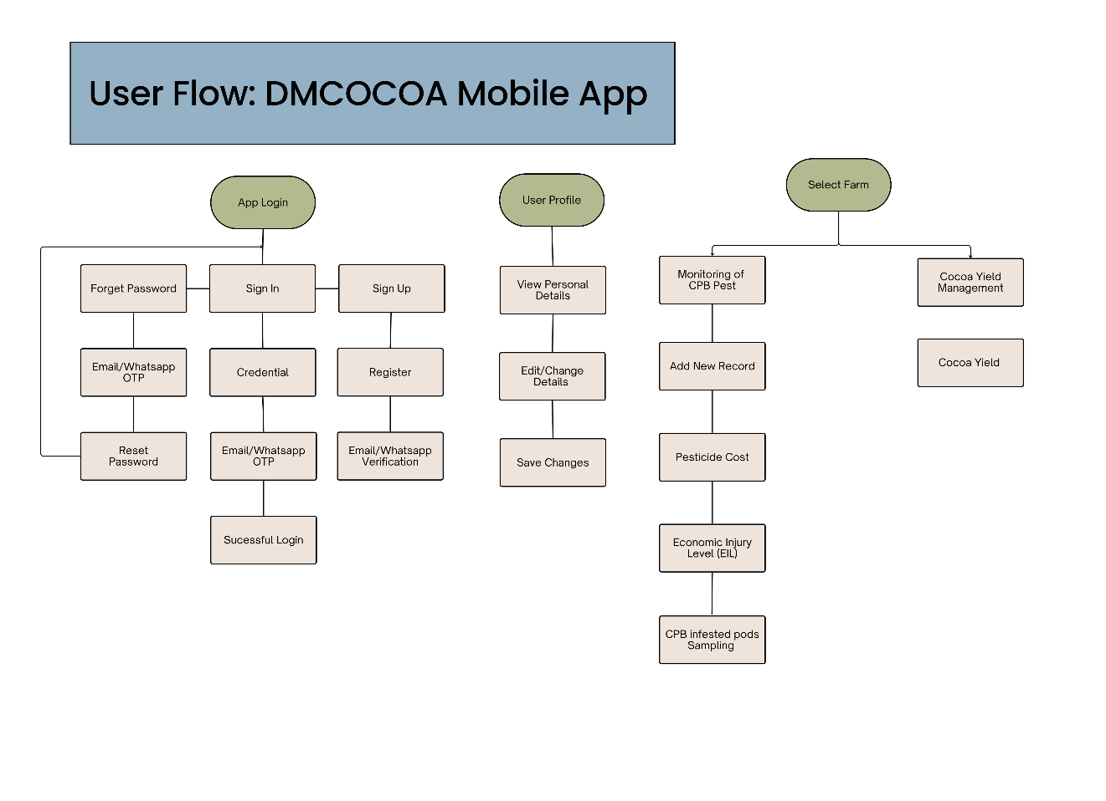

Overall, the DMCOCOA user flow ensures a smooth and structured interaction experience. Starting from secure authentication, followed by personalized profile management and progressing to two main functional areas: pest monitoring and yield management. The design emphasizes simplicity, accessibility, and support offline for rural users, aligning with the project’s goal to assist cocoa farmers with AI-driven decision-making tools

**4.2 Flow Charts**  
**User Registration**

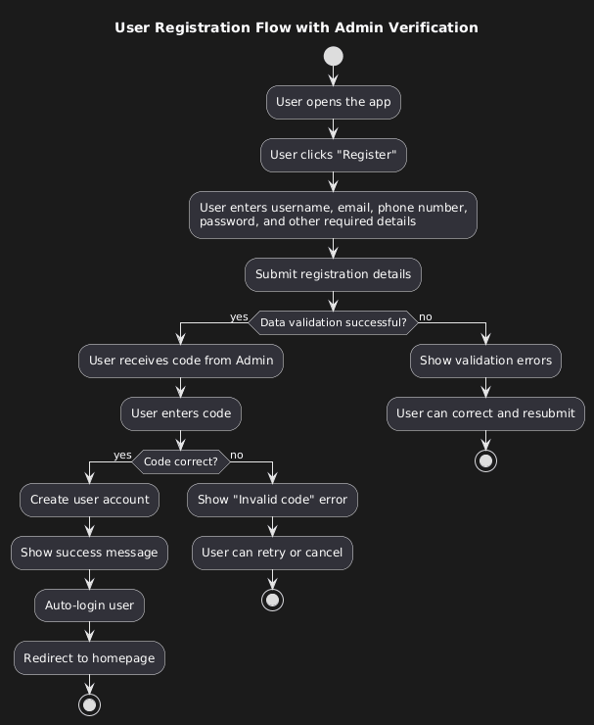

User registration flow implements an admin-verified signup process that begins when a user opens the application and selects the registration option. The user first provides essential details including username, email, phone number, and password, which the system validates for correctness and completeness. If the data fails validation, error messages guide the user to make corrections and resubmit the form. Once validation passes, the process transitions to a unique admin-mediated verification step where the user must obtain a registration code directly from an administrator outside the application. The user then enters this code into the app, and if correct, the system automatically creates the account, logs the user in, displays a success message, and redirects them to the homepage. If the code is invalid, the user sees an error and can either retry or cancel the registration altogether. This two-tiered approach ensures both data quality and administrative control over new user onboarding.

**Login**

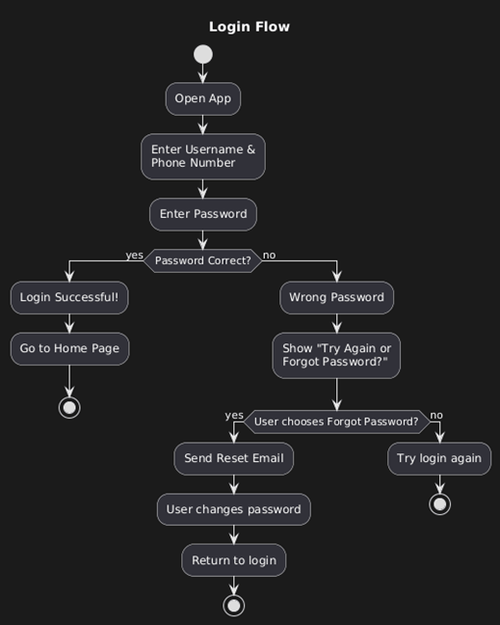

login flow provides a straightforward authentication process with built-in password recovery options. When users open the application, they begin by entering their username and phone number as primary identifiers, followed by their password for verification. If the password is correct, the system grants access immediately, logging the user in and redirecting them to the home page. However, if the password is incorrect, the system offers users a choice between retrying the login or utilizing the "Forgot Password" feature. When users select the password recovery option, the system sends a reset email to their registered account, allowing them to change their password securely before returning to the login screen to attempt signing in again with their new credentials. This balanced approach maintains security while providing clear recovery paths for users who encounter authentication issues.

CPB Pest Monitoring

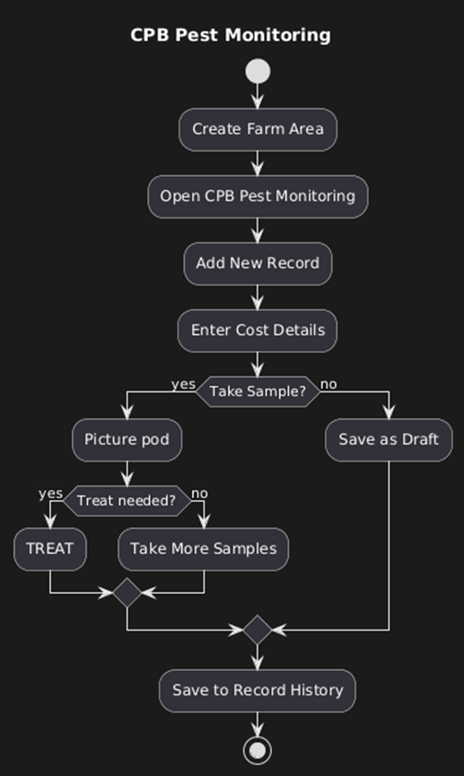

CPB Pest Monitoring flow outlines a systematic approach to agricultural pest management that begins with creating a designated farm area within the system. Once the farm area is established, users access the CPB Pest Monitoring module to initiate new records by first entering cost details related to pesticide and labor expenditures. The process then branches based on whether the user decides to take a pod sample for analysis. If no sample is taken, the record is temporarily saved as a draft for future completion. When sampling occurs, users capture images of pods and assess whether treatment is necessary based on their observations. If treatment is required, the system records a TREAT action; if not, or if the assessment is uncertain, the user is directed to collect additional samples for further analysis. Finally, all completed monitoring data whether treatment actions or continued sampling decisions is saved to the permanent record history for tracking and future reference.

Cocoa Yield Management

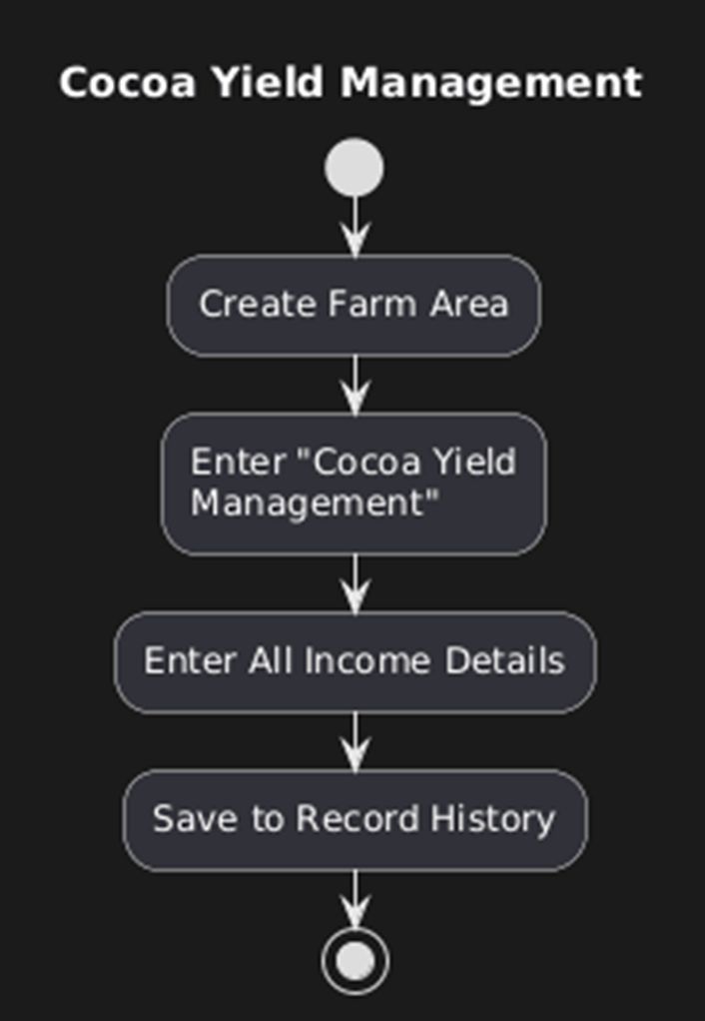

Cocoa Yield Management flow presents a streamlined process for tracking agricultural revenue within a dedicated farming management system. The workflow begins by establishing a designated farm area, providing the foundational context for all subsequent financial tracking. Users then specifically access the "Cocoa Yield Management" module, which serves as the specialized interface for income documentation. Within this module, users comprehensively enter all income details derived from cocoa production, capturing the complete financial yield from their agricultural activities. Once all revenue information has been recorded, the system securely saves this financial data to the permanent record history, creating a reliable archive of production income that supports future analysis, reporting, and business decision-making for the farming operation.

User Profile

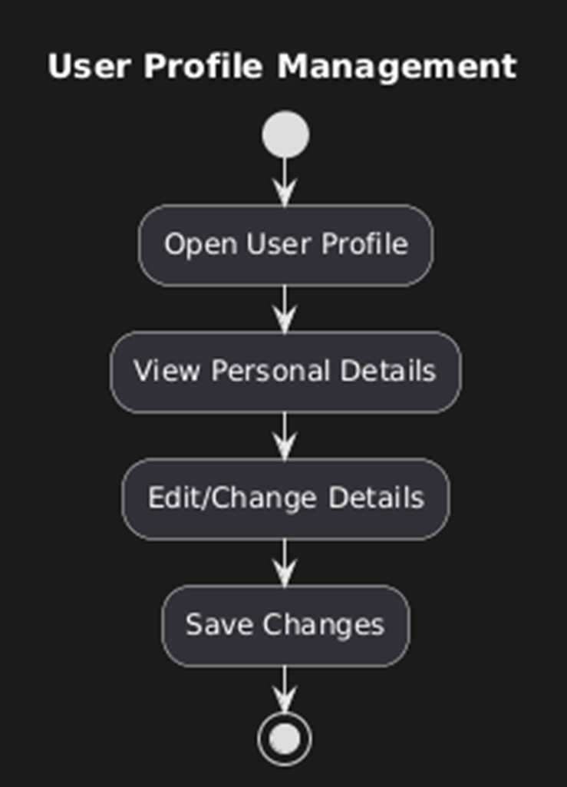

User Profile Management flow illustrates a straightforward and intuitive process for personal account management within the application. Users begin by accessing their profile section where they can immediately view their current personal information displayed in a readable format. The interface then allows users to seamlessly transition into editing mode, where they can modify any of their personal details such as contact information, preferences, or other account-related data. Once the necessary changes have been made, users simply save their updates, which the system processes and stores immediately. This linear and uncomplicated approach ensures that profile management remains accessible to all users while maintaining the functionality needed for personal data maintenance.

Menu

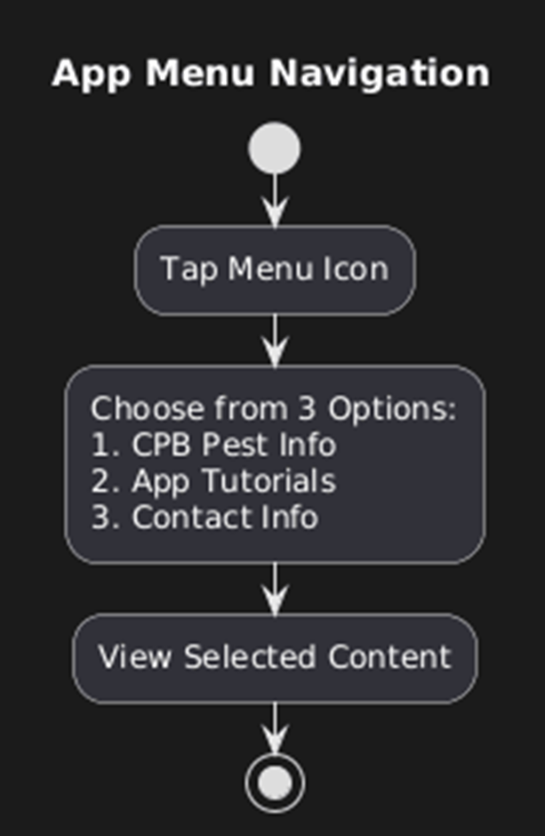

App Menu Navigation flow demonstrates a clean and user-friendly interface design centered around a hamburger menu icon. When users tap the recognizable three-line menu icon, they are presented with three clearly organized options that cover the essential aspects of the application. The first option provides educational content about CPB Pest information, serving as a learning resource for users. The second option directs users to comprehensive app tutorials that guide them through various features and functionalities. The third option offers access to contact information, enabling users to reach out for support or inquiries. Once a selection is made, the system immediately displays the corresponding content, creating a seamless navigation experience that allows users to quickly access the information they need without unnecessary complexity or intermediate steps.

**5. UI/UX Designs**

**Sign-In pages**

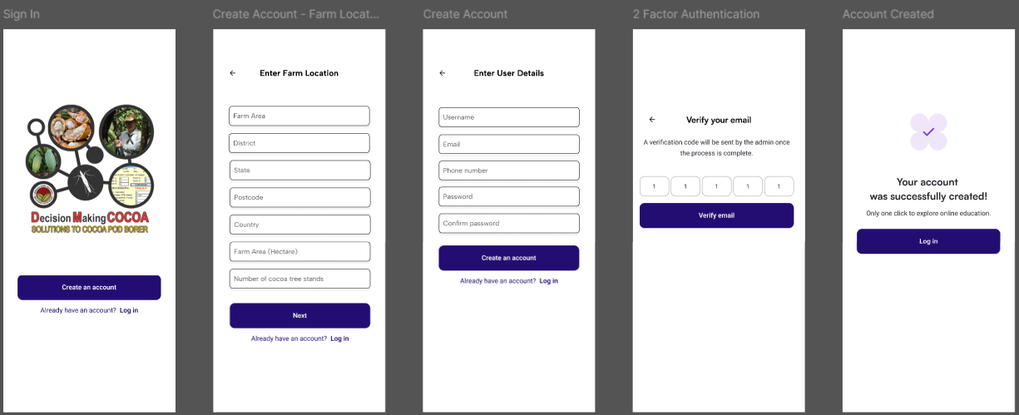

Multi-step registration form demonstrates significant UI/UX improvements through its segmented approach that breaks the complex process into three manageable stages farm location details, personal information, and admin verification. The design effectively reduces cognitive overload by organizing related fields into logical groups with clear section headers, while maintaining consistent navigation options like the "Already have an account? Login" links throughout the process. The clean visual hierarchy, adequate spacing between form sections, and progressive disclosure of information create an intuitive user journey that guides farmers smoothly from initial farm data entry through final account verification, making what could be an overwhelming registration feel structured and achievable.

**Login pages**

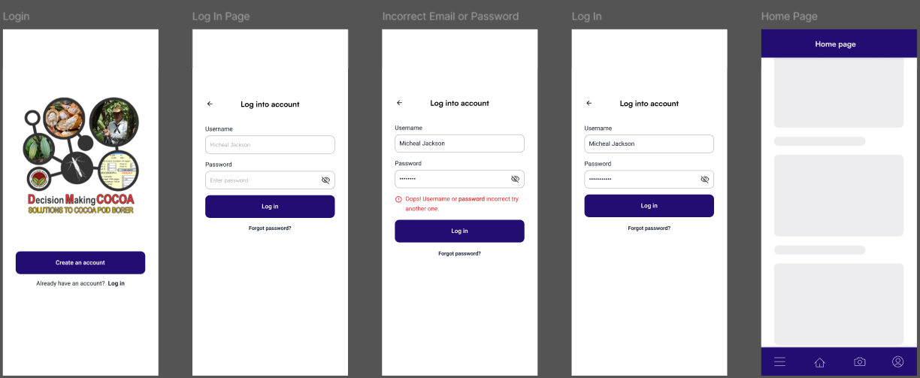

Interface demonstrates clear UI/UX improvements through its intuitive error handling and user guidance system. The design effectively addresses common login frustrations by providing immediate, specific feedback when credentials are incorrect—explicitly stating "Incorrect Email or Password" rather than generic error messages—while maintaining the entered username to reduce user effort in retyping. The consistent placement of "Forgot Password?" options and "Create an account" links throughout the process ensures users always have recovery paths available. The visual design maintains clean form organization with clear field labels and adequate spacing, creating a straightforward authentication journey that minimizes confusion and successfully guides users from initial entry through to the home page access.

**Record History pages**

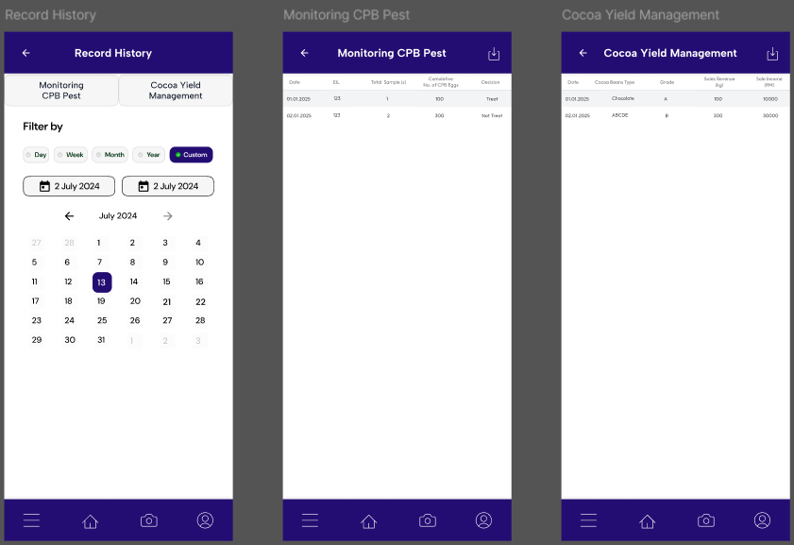

The implementation of multiple filtering options—by day, week, month, or year—provides users with versatile ways to access historical data, while the visual calendar interface offers intuitive date selection. The clean separation between different record types (Monitoring CPB Pest and Cocoa Yield Management) with distinct section headers helps users navigate between datasets efficiently, transforming what could be overwhelming agricultural data into an accessible and actionable information system for tracking farm performance over time.

**Monitoring of CPB Pest pages**

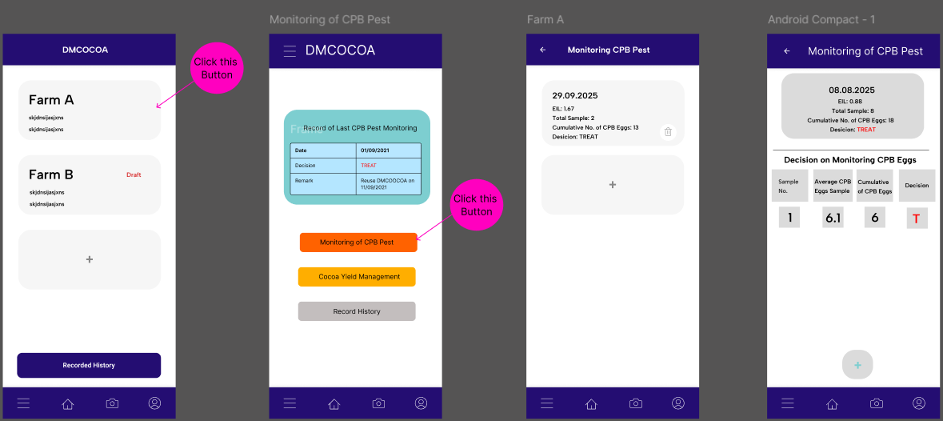

The design creates a clear hierarchical navigation where farmers first select a specific farm (Farm A or Farm B) and then choose between three specialized functions: Monitoring CPB Pest for pest management decisions, Cocoa Yield Management for income tracking, and Record History for data review. The Monitoring CPB Pest module effectively guides farmers through a decision-making workflow from recording pesticide costs and sampling pods to receiving clear TREAT recommendations that directly translate to real-world actions like spraying entire areas. The interface smartly displays key metrics like ECL levels, sample counts, and cumulative pest eggs in easily digestible cards, transforming complex agricultural data into actionable insights that support immediate farming decisions while maintaining comprehensive historical records for ongoing farm management.

**Embracing Iterative Design**

The current Figma designs represent a promising starting point rather than a final product, reflecting the essential reality that successful digital solutions emerge through continuous collaboration and learning. As we engage more deeply with our clients and gain clearer insights into their actual farming operations, both the user flows and interface designs will naturally evolve to better serve real-world agricultural needs. This iterative process is not a setback but rather a fundamental strength of user-centered design methodology each client discussion reveals new layers of understanding about daily farming workflows, decision-making processes, and practical constraints that must inform the product's development. Our team recognizes that this ongoing dialogue and willingness to adapt are what will ultimately transform good initial concepts into truly effective tools that farmers will embrace and value in their daily operations, ensuring the final product aligns not just with technical requirements but with the genuine needs of those working in cocoa cultivation and pest management.

**6. Role-based Permission Table**

This permission table defines the Role-Based Access Control (RBAC) system for the DMCOCOA application, specifying exactly what actions users in the Admin and Cocoa Farmer roles are authorized to perform.

|  |  |  |  |  |
| --- | --- | --- | --- | --- |
|  |  | **Roles** | |  |
| **Feature/Page** | **Input Fields/Descriptions** | **Admin** | **Cocoa Farmer** | **Notes** |
| Register for an account | **User Details**   * Full Name * State * District * Postcode * Phone number   **Farm Details**   * Farm Location A Name * Farm Area (hectare) * Number of cocoa tree stands * +Farm Location? | Close with solid fill | Checkmark with solid fill | Admin will be given special credentials as they will be hardcoded into the system and nobody can register as an admin. |
| Log in & log out |  | Checkmark with solid fill | Checkmark with solid fill | 2 Factor Authentication needed when logging in. |
| User Profile |  | Checkmark with solid fill | Checkmark with solid fill | View/Edit personal profile details |
| Farm Selection Page | * Farm Name * Farm Location * Farm Area (hectare)     **Record History Tab** | Checkmark with solid fill  View Farms | Checkmark with solid fill  Select/Add Farm | Farm locations that each farmer oversees. |
| User Management Page |  | Checkmark with solid fill | Close with solid fill | CRUD, view farmer details |
| **CPB Pest Monitoring**     * Pesticide Cost Page * Economic Injury Level (EIL) calculation page | **Pesticide Cost Page**   * Date * Pesticide Brand * Pesticide Price per litre (RM) * Number of Spray Pumps Required per hectare * Pesticide Amount per Litre of Mixture (***l***) * Pesticide Cost (*auto-calculated field*)     **Economic Injury Level (EIL) Calculation page**   * Total labour cost per day (RM) * Farm Area Sprayed per Day (Hectares) * Work Cost per Hectare (RM) (*auto-calculated field*) * Frequency of Pesticide Use per Year * Wet Cocoa Beans Price per Kg (RM) * Wet Cocoa Beans Produced per Hectare (kg) * K (Proportionate reduction in injury) (*Read-only field*)     **CPB infested Cocoa Pod Sample (1)**   * Economic Injury Level (EIL) (*read-only field*) * Number of CPB Eggs Per Pod   +Pod 1 (Camera icon)  +Pod 2  (Camera icon)  +Pod 3  (Camera icon)  +Pod 4  (Camera icon)  +Pod 5  (Camera icon)   * Cumulative Number of CPB Eggs (*auto-calculated*) * Average CPB Eggs per Sample (*auto-calculated*) | Checkmark with solid fill  View data | Checkmark with solid fill  Input Fields |  |
| Decision on Monitoring CPB Eggs | * Sample No. * Cumulative Number of CPB Eggs * Average CPB Eggs per Sample * Pesticide Spraying Decision (Treat/Continue Collecting Samples) (*Auto-decided*) | Checkmark with solid fill  Read-only | Checkmark with solid fill  Input Fields |  |
| Cocoa Yield Management | * Date * Cocoa Beans Type (Wet/Dry) * Grade * Sales Income (RM) * Sales Revenue per kg of cocoa beans (RM) * Remarks | Checkmark with solid fill  Read-only | Checkmark with solid fill  Input Fields |  |

# **Software Development Life Cycle (SDLC)**

|  |  |  |  |  |
| --- | --- | --- | --- | --- |
| Phase | Key Activities & Deliverables | Sprint Start | Sprint End | Sign-off |
| 1. Requirement Analysis & Planning | • Finalize Problem Statement & Scope with Lembaga Koko Malaysia. • Stakeholder Analysis & define high-level requirements. • Feasibility Study: Confirm technical approach (Flutter + Firebase + On-Device AI). • Create Project Plan & Team Charter. • Deliverable: Signed Team & Project Plan Document. | 16/09/2025 | 26/09/2025 | Supervisor & Client |
| 2. System Design | • Architecture Design: Finalize system diagrams (Flutter App, Firebase Services). • UI/UX Design: Create wireframes & prototypes for the mobile app. • Database Design: Define Firestore data structure (Users, Scan History). • AI Model Specification: Choose model architecture (YOLO/Mobilenetv2) and data pipeline. • Deliverable: System Design Document & UI/UX Prototype. | 27/09/2025 (Sprint 1) | 10/10/2025 (Sprint 1) | Supervisor & Client |
| 3. Implementation (Sprint 2) | • Setup Development Environment: Flutter, Firebase project, Git repo. • Develop Core App Skeleton: Navigation, basic UI. • Implement Firebase Auth & Firestore integration. • Build Image Capture & Gallery Module. • Deliverable: Functional app skeleton with auth and basic UI. | 13/10/2025 (Sprint 2) | 26/10/2025 (Sprint 2) | Supervisor & Client |
| 4. Implementation (Sprint 3) | • AI Model Development (Parallel): Data collection, annotation, model training & conversion to TFLite. • Integrate On-Device AI Engine: Add TFLite plugin and integrate the model for inference. • Implement Decision Logic Module (ETL calculation). • Deliverable: App with working, offline CPB egg detection. | 27/10/2025 (Sprint 3) | 09/11/2025 (Sprint 3) | Supervisor & Client |
| 5. Implementation (Sprint 4) | • Implement History & Data Sync: Local cache & Firestore synchronization. • Polish UI/UX and implement 2FA. • Performance Optimization and battery usage testing. • Deliverable: Feature-complete Beta version. | 10/11/2025 (Sprint 4) | 23/11/2025 (Sprint 4) | Supervisor & Client |
| 6. Testing | • Unit & Integration Testing: Test AI model accuracy, app functions, and Firebase rules. • User Acceptance Testing (UAT): Conduct testing with a group of cocoa farmers. • Security & Performance Testing. • Bug Fixing & Refinement based on feedback. • Deliverable: UAT Report & Stabilized App. | 24/11/2025 | 13/12/2025 | Client & End-Users |
| 7. Deployment & Handover | • Deploy to App Stores: Submit to Google Play Store. • Final Server Setup: Configure production Firebase project. • User Training & Documentation handover. • Project Post-Mortem & Final Report. • Deliverable: Live Application & Project Closure Document. | 14/12/2025 | 19/12/2025 | Supervisor & Client |

# **Contribution summary (This Sprint)**

|  |  |  |  |  |  |  |  |  |
| --- | --- | --- | --- | --- | --- | --- | --- | --- |
|  | Contribution | Initiatives | Communication | | | | | Respect |
| Eddie Pui Yung Yew | Yes  Complete the tasks for documenting, data annotation and build the yolov8 environment | Yes  Doing research on the object detection model and image classification model that suitable for our project | Yes  I attend all the team meetings every Tuesday and some Thursday. | Yes,  Attend all the supervisor meetings on Tuesday too | Yes,  Attend all the client meetings every Wednesday too | Yes,  Replies to all the message through WhatsApp as soon as possible | Yes,  Provide regular updates on the sprint backlog item and ask for feedback from the team. | Yes,  Listen to everyone’s opinions in the team and discuss the best solution to the problem. |
| Julian Chet Shiang JEE | Yes  Complete tasks for document management, data collection and annotation, Gantt and burndown chart for backlogs items with specified details. | Yes  Finding solutions and research for mobile backend development using Google Firebase products instead of other methods such as Digital Ocean and Django for customized backend API. Initiate research into using Figma before UI/UX designs and create Trello sprint to develop agile environment. | Yes  Attends team meetings every Tuesday and some Thursday based on everyone’s schedule. | Yes  Attend all supervisor meetings on Tuesday. | Yes  All clients’ meetings are held on Wednesday morning and at nighttime depending on clients’ request. | Yes  Replies to messages to ensure everything is on time and processed thoroughly to avoid misunderstandings and maintain a good communication environment. | Yes  Updates status of any task to team members and clients when asked or inquiries more questions to client and supervisor for more advice and feedback on the task. | Yes  Always answer rationally and respectfully to both team members, clients and supervisor to show professionalism and dedication to the project. |
| Yee Von LOW | Yes  Completed the UX/UI design and user flow of the mobile app and improved the overall quality of the app flow. | Yes  Tested the client’s previously developed app and discovered several errors. We provided our suggestions to the client for improvement. | Yes  We hold internal meetings every Tuesday and Thursday, either during class or after class. | Yes  We attend all supervisor meetings on Wednesday mornings. | Yes  We attend all client meetings on Wednesday mornings. | Yes  Replied to messages within working hours. | Yes  Provided regular updates and confirmations on progress to avoid misunderstandings. | Yes  Listened to different perspectives from team members, clients, and the supervisor, as their opinions may be useful for implementation. |
| Zhe Hong VOONG | **Yes-**  Completed AI tasks (YOLOv8 setup, data annotation, model training) on time and with good quality. | **Yes** –  Took initiative in setting up Google Colab environment, train model and exploring ESPCN for super-resolution. | **Yes-**  We have a meeting every Tuesday and Thursday after class. | **Yes-**  Every Tuesday and Thursday | **Yes-**  Every Wednesday 10am-12pm | **Yes-**  Always replied promptly through WhatsApp's group chat and meetings. | **Yes**-  Consistently updated team on AI progress and dataset preparation. | **Yes**  Always showed respect and cooperated well with teammates’ ideas. |
| Tsung Yin NG | Yes  Tasks assigned were done accordingly. Actively contributed in the prototyping phase of the mobile app in this sprint. Elements Mobile app flow upgrade with permission table. Meeting minutes are also taken on time. | Yes  Took much time to explore and try to understand how the existing mobile app provided by the client works while constantly communicating with the client once a problem appears for clarification. Suggest new functions and sought client approvals to proceed with prototyping. | Yes  Attended all meetings held by the team every Tuesday and Thursday either in class or at another location. | Yes  Attended all supervisor meetings when it is called for, mostly on Tuesdays. | Yes  Attended all meetings with client every Wednesday | Yes  Ensure clear responses every time prompted or asking for approvals/signatuers within working hours. | Yes  Updates progress and seek client approvals after being done with a task. | Yes  Respects all proposals, decisions, and opinions to maintain team harmony and cooperate with clients in a respectful manner. |
| Ryan NG  Hoe Kuene | Yes, completed tasks within dateline while maintaining quality | Yes, did researched and explore to try and understand how the existing mobile app works in order to improve it | Yes, attended every meeting after class | Yes, attended all supervisor meeting | Yes, I’ve attended every meeting with our client | Yes, replied to maintain good communication | Yes, constatnly updating the team regarding reports and seek for opinion | Yes, showed respect to peers and open to consider from different point of view |

# **Contribution Details (This Sprint)**

**Eddie Pui Yung Yew**

**Documented Sprint Report:**

* **Wrote the Sprint Review and Sprint Restrospective sections of the sprint report.**
* **Gather feedback from all team members regarding the sprint’s progress, including what went well and challenges that the team faced**
* **Summarized team opinions to ensure the report accurately reflected the team’s key takeaways**

**Technical Research for Model Selection:**

* **Researched the object detection and image classification models to determine which best fit the project’s problem requirements. (MobileNetV2 and Yolov8)**

**Data annotation on the Cocoa Pod Image:**

* **Annotated 44 numbers of images using Roboflow by marking the eggs location on the cocoa pod.**
* **Applied data augmentations techniques to generate additional images from different dimensions to increase the number of train datasets.**

**Evidence:**

* The **MobileNetV2** and **YOLOv8** models will be used for the AI component of the project.
* **Data annotation photo evidence** is provided in the **Sprint Progress Evidence** section.

**Julian Chet Shiang JEE**

**Project Management & Planning:**

* **Spearheaded the setup and maintenance of the project's agile framework** by creating and managing the Trello board, ensuring all tasks were tracked through "To Do," "Doing," and "Done" columns, which provided real-time visibility into the team's progress.
* **Developed a comprehensive Gantt Chart** outlining the entire project timeline, key deliverables, and dependencies, which served as the master plan for tracking progress against deadlines throughout the project lifecycle.
* **Authored the Software Development Life Cycle (SDLC) section** of the report, defining the phased approach from planning to deployment and establishing clear sprint goals and sign-off procedures.

**Technical Research & Architecture:**

* **Researched and compared backend solutions**, conducting a detailed analysis of Firebase against alternatives like Digital Ocean and Django. This research directly informed the decision to adopt Firebase for its scalability, integrated services, and rapid development capabilities.
* **Designed and documented the initial Technology Stack**, selecting and justifying the use of Flutter, Dart, and the specific suite of Firebase services (Auth, Firestore, Storage) that form the backbone of the application.
* **Created the Methodology diagram** (media/image1.png), which visually communicates the high-level workflow and integration between the mobile app, AI model, and backend services.

**AI/ML Data Preparation:**

* **Contributed to the AI pipeline by performing data annotation** using the Roboflow platform, preparing the initial dataset for model training by accurately labeling cocoa pod images.

**Communication & Documentation:**

* **Ensured all project management artifacts (Trello, Gantt Chart, SDLC) were consistently updated** and accessible to the entire team, facilitating transparency and coordination.
* **Actively participated in all client and supervisor meetings**, providing updates on the project plan and architectural decisions, and seeking feedback to align the team's direction with stakeholder expectations.

**Evidence:**

* Trello board within this report.
* Screenshots of the Gantt chart as included in the report.
* The documented SDLC and Technology Stack sections within this report.
* The Methodology diagram.

**Yee Von LOW**

**Designed and improved UI/UX in Figma**

**Streamlined Onboarding & Profile Management:**

* Separated the User Registration and User Profile screens to eliminate confusion.
* Split farm information and personal details into distinct sections to provide administrators with comprehensive farmer profiles.
* Clarified the login and registration flows for an internal, admin-verified user base.

**Intuitive Main Navigation**

* Designed a clear hamburger menu with three primary options such as CPB Pest Info, App Tutorials, and Contact Information.

**Redesigned & Logical Pest Monitoring Flow:**

* Transformed a complex data entry process into a guided, step-by-step workflow.
* Created a clear sequence such as Enter Costs -> Take Samples -> Get a System-Generated Decision (TREAT / Continue Sampling).
* Implemented critical system logic. Once a "TREAT" decision is made, the system locks new samples for 10 days, enforcing correct agricultural practice and ensuring data integrity for administrators.

**Simplified and Dedicated Function Modules:**

* Designed straightforward flows for Cocoa Yield Management (income tracking) and Record History (data review).

**User-Friendly Data Presentation:**

* Improved the Record History and Homepage screens to display complex data (like EIL, sample counts, and decisions) in an easily scannable, card-based format.

**Client-Collaborative Design Process:**

* All designs are treated as iterative prototypes, constantly refined based on client feedback to truly reflect how the farm operates.
* The core design goal is to hide high-complexity calculations such as Economic Injury Level behind a simple, intuitive, and user-friendly interface.

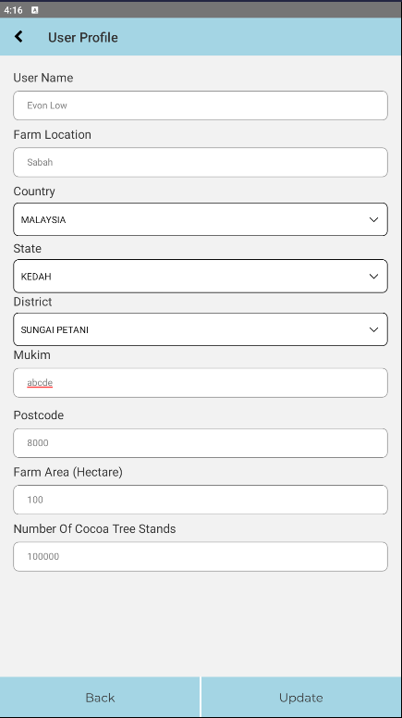**Testing Existing Application & Identifying Errors**

The current design creates significant user confusion by using identical layouts for both registration pages and user profile sections, making it difficult for first-time users to distinguish between initial setup and profile management. This problem is compounded by the absence of a dedicated login page, leaving users uncertain about their authentication status. Furthermore, the registration process currently focuses exclusively on farm information such as farm location, area size, and tree counts while completely overlooking personal details about the farmers themselves. This limitation prevents administrators from having comprehensive user records. To address these issues, I propose separating the farm information and personal details into distinct sections within both registration and profile management. This reorganization will provide clearer user navigation while ensuring administrators have access to complete farmer profiles that include both agricultural operations and individual contact information, better serving the internal-use-only nature of this proprietary application.

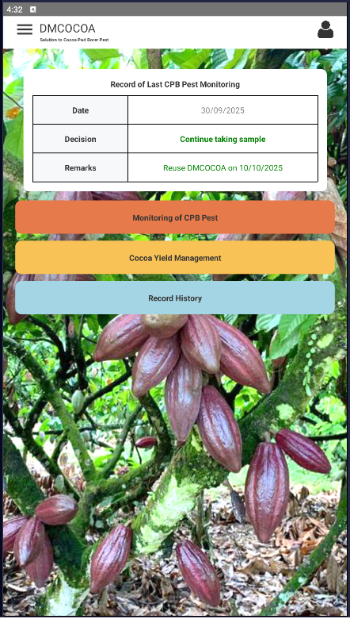The homepage appearance, while visually clean and straightforward, masks a highly sophisticated decision-making engine operating behind the scenes. The complexity lies in the intricate calculations where every data entry from pod counts to pest observations triggers cascading effects throughout the entire monitoring system, ultimately determining critical treatment recommendations like "Continue taking sample" or "TREAT." This substantial gap between surface simplicity and underlying complexity is precisely why our user flows and Figma designs remain in development. Our client has consistently emphasized that user-friendliness is paramount, recognizing that farmers need an intuitive interface that conceals the sophisticated algorithms processing their inputs. We are therefore deeply engaged in understanding the agricultural science and decision-making processes that drive their system, ensuring our designs translate these complex calculations into clear, actionable steps that farmers can navigate confidently without needing to comprehend the technical intricacies operating beneath the surface.

|  |  |  |
| --- | --- | --- |
|  | | |
| Picture 1 | Picture 2 | Picture 3 |

This comprehensive Monitoring CPB Pest interface reveals a sophisticated agricultural decision-support system that guides farmers through a structured pest management workflow. The process begins with essential economic calculations where farmers input detailed cost variables including pesticide prices, labor rates, and farm productivity metrics all crucial factors that determine the Economic Injury Level (EIL) threshold. Once these foundational costs are established, farmers proceed to the sampling phase where they systematically collect and record pod borer egg counts across multiple samples. The system's intelligence shines through its dynamic decision-making as farmers input sample data, the system continuously calculates cumulative pest percentages and automatically generates treatment recommendations. The critical design constraint that once the system recommends "TREAT," farmers cannot add more samples but must immediately treat the entire hectare ensures timely pest control while preventing decision paralysis. This seamless integration of complex agricultural economics with practical field operations demonstrates how we're transforming intricate scientific calculations into clear, actionable guidance that empowers farmers to make data-driven pest management decisions without requiring deep technical expertise.

|  |  |
| --- | --- |
| A screenshot of a phone  AI-generated content may be incorrect.  Picture 4 | Picture 5 |
|  |

This monitoring history reveals both the current implementation and the critical logic correction needed for an effective pest management system. The interface successfully displays historical records with clear decision outcomes, allowing farmers to track their monitoring activities over time. However, the development team identified a fundamental workflow issue the system incorrectly allows continuous record-adding even after a "TREAT" decision has been made. Through client collaboration, we've established the correct agricultural protocol once the system determines "TREAT" is necessary, farmers must immediately address the pest infestation and cannot add new samples for 10 days. This mandatory treatment period ensures proper pest control before resuming monitoring activities. The redesign will implement this logical constraint, creating a more structured workflow that aligns with real-world agricultural practices while maintaining the clean, accessible interface that allows farmers to easily review their historical data and understand the progression of their pest management efforts over time.

Important addition addresses a critical real-world challenge in agricultural data collection farmer compliance. Recognizing that some farmers might delay or skip necessary "TREAT" actions due to various constraints, the development team has proposed an automated enforcement mechanism. The system will now automatically initiate the 10-day countdown once a "TREAT" decision is recorded, preventing farmers from entering new monitoring data during this mandatory treatment period. This smart constraint serves dual purposes: it ensures proper pest control protocols are followed while maintaining the integrity of the historical data that administrators rely on for future agricultural decisions. By removing the possibility of bypassing treatment requirements, the system guarantees that the data reflects actual field conditions and interventions, transforming what could be subjective farmer compliance into an objective, system-enforced workflow that produces reliable, actionable intelligence for the entire farming operation.

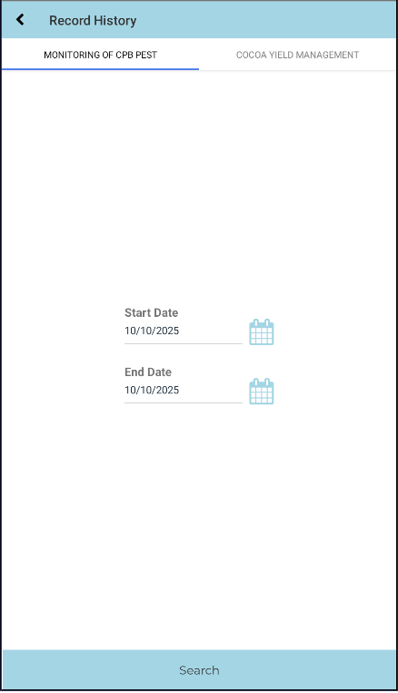 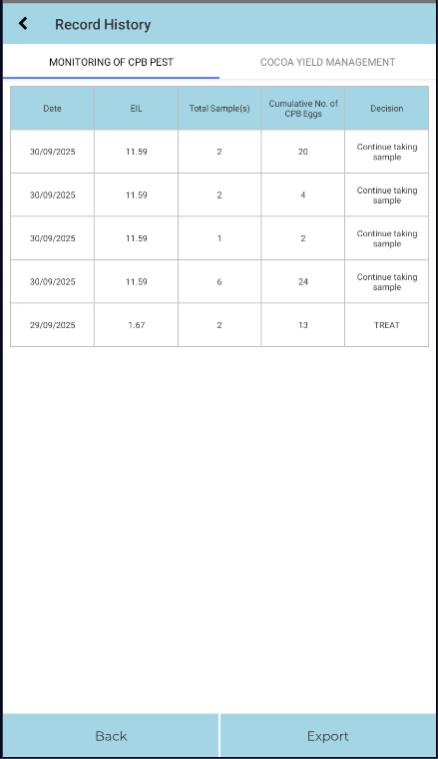

Record History interface provides a functional foundation for accessing historical farm data, featuring clear category segmentation between Monitoring of CPB Pest and Cocoa Yield Management records. The current design successfully distinguishes between these two critical data types and includes essential search functionality with date filtering capabilities. To enhance user experience, the development team will focus on simplifying the navigation flow and making the search process more intuitive. The redesigned version will prioritize straightforward access to historical records with improved visual hierarchy, clearer date selection mechanisms, and more prominent search features that allow farmers to quickly locate specific records without unnecessary complexity.

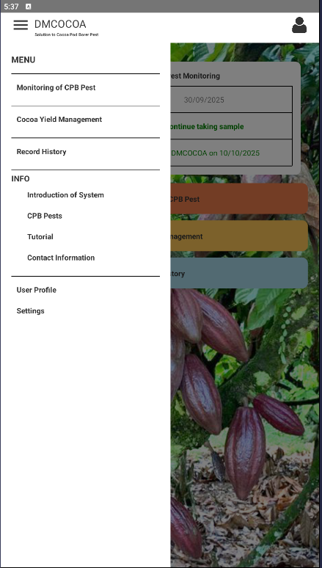Current menu structure provides a solid foundation with its clear categorization of core functions including Monitoring of CPB Pest, Cocoa Yield Management, and Record History. While the basic layout functions adequately, the opportunity lies in refining the menu to eliminate unnecessary features and prioritize the most valuable content for farmers. The proposed enhancements focusing on administrator contact information, CPB pest educational materials, and beginner-friendly tutorials demonstrate a user-centered approach that addresses real farmer needs. This streamlined strategy ensures that first-time users can quickly access learning resources while experienced farmers efficiently navigate to daily operational tools. The ongoing collaboration between developers and clients remains crucial for determining the optimal balance between comprehensive functionality and simplicity, ensuring the final menu design serves as an intuitive gateway rather than a confusing obstacle, ultimately supporting farmers in their daily pest management and yield tracking activities without overwhelming them with non-essential options.

**Evidence: Link to Figma prototype**

<https://www.figma.com/design/yrFi1L2ttE6lkbtDIebznU/DMCOCOA?node-id=0-1&t=AhY5UDQiWFsTBj17-1>

**Zhe Hong VOONG**

**AI Model Development & Research:**

* **Configured and initialized the YOLOv8 environment** in Google Colab, installing required dependencies (Ultralytics, PyTorch) and verifying GPU compatibility for training efficiency.
* **Integrated the Roboflow dataset** by structuring and validating training (train/) and testing (test/) directories, ensuring the data.yaml file correctly referenced image paths for YOLOv8 compatibility.
* **Trained the YOLOv8-L model** using the prepared dataset to establish the baseline detection performance for Cocoa Pod Borer (CPB) egg detection..
* **Researched and finalized the Super-Resolution algorithm** — selected **ESPCN (Efficient Sub-Pixel Convolutional Neural Network)** due to its low computational load and suitability for real-time inference on mobile devices.
* **Defined the AI pipeline structure**, specifying stages for preprocessing, detection, and decision support based on egg-density thresholds.

**Data Preparation & Annotation:**

* **Performed dataset quality checks and augmentation** using Roboflow tools to improve model robustness under varying lighting and focus conditions.
* **Verified and adjusted annotation consistency** to ensure accurate label-to-image mapping before model training.
* **Coordinated with the client (Dr. Albert and Mr. Felix)** to request additional high-resolution and zoomed-in images to improve the dataset diversity and detection precision.

**Technical Implementation & Documentation:**

* Authored documentation describing the **AI module setup process**, including dataset directory configuration, YAML syntax, and training command structure for replication by other team members.
* **Recorded performance logs and environment setup evidence** (Google Colab notebooks, screenshots of dataset folders, and YOLOv8 training configuration).
* Collaborated closely with the project lead to align AI component milestones with Sprint 1 deliverables and SDLC timeline.

**Evidence:**

* Data annotation and augmentation photo evidence is provided in the Sprint Progress Evidence section.
* Screenshots of the YOLOv8 environment setup and successful model initialization in Colab are also provided in the Sprint Progress Evidence section.
* Communication records with client regarding ESPCN model selection.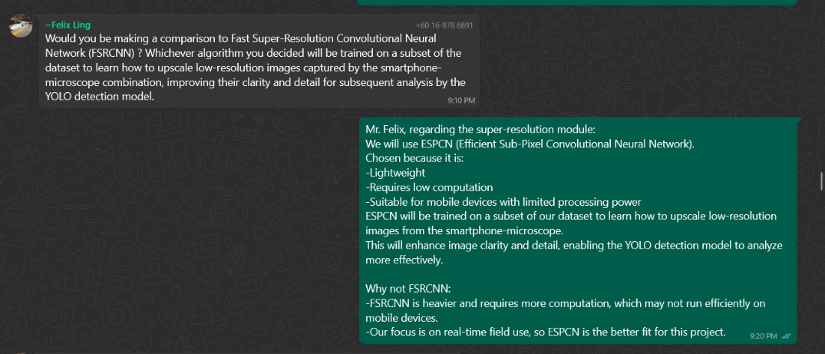

**Tsung Yin NG**

**Documented Meeting Minutes**

* **Prepare agenda for every meeting either with client or just among the team members.**
* **Taking notes of what is needed and what has been clarified during the meeting**
* **List out action items for project progression.**
* **Requests look-through and approval (signatures) from attendees.**

**Involved in Mobile App and Website development Prototyping**

* **Played a part in translating client requirements into prototypes for mobile application and made suggestions for admin’s management website.**
* **Constructed the outline of the Software Requirements Specification (SRS) Version 1, with detailed descriptions of the introduction and functional requirements.**
* **Developed the Role-Based Permission Table, defining access controls for both admin and cocoa farmers across different system modules.**
* **Supported the prototyping phase by providing critical input on user workflows and system functionality based on direct client feedback.**

**Evidence:**

**1.** Organised weekly meetings in a combined word file, while separating individual ones out for approval and taking signatures. Took evidence of the meetings by taking pictures.

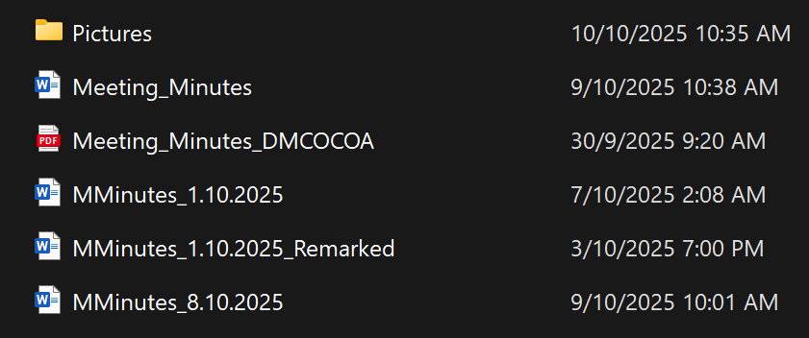

2. SRS in this sprint report.

3. Sketches and discussion of mobile application design and functions.

**Ryan NG Hoe Kuene**

**Documented Importance of Meeting:** By recording audio in every meeting discussion with client to ensure all ideas and decisions were captured.

**Gantt Chart:** Created project’s Gantt chart to track progress, assign tasks in order to manage deadlines effectively

**User Flow:** Designed and update the user flow diagram to visualize the navigation and interaction process within the mobile application.

**Mobile App Prototype:** Assisted in developing the Figma prototype by designing couple page and contributing to the overall interface layout.

**Lesson Learned and Future Plan:**

Contributed some to the Lessons Learned and Future Plan sections by summarizing team experiences and outlining improvement for future plans.

**Report Writing on Software Requirement Specifications (SRS):**

Constructed the **Project Overview** for mobile app and website development.

Developed the **Goals and Objectives** section.

Wrote the **Non-Functional Requirements** section.

**Evidence:**

* **Gantt Chart and User Flow Diagram is provided in the report**
* **Did Figma Prototype on CPB Pest Page shown above**
* **Project Overview, Goals and Objectives, Non-Functional Requirement is included in this document**
* **Proof of Audio Recording**

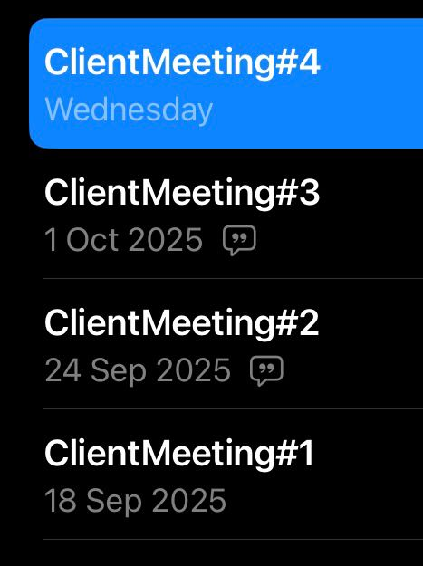

# **Sprint plan**

[A detailed plan for the sprint. A list of items selected for the sprints should be presented in a sprint backlog, along with the estimated time. This can be in hours or story points. This section should give a clear picture of what the team wanted to deliver at the end of the sprint.]

|  |  |  |
| --- | --- | --- |
| Sprint Backlog Item | Definition of Done | Estimated Time (Hours) |
| Mobile Module | | |
| UI/UX Prototyping | UX/UI design of the mobile application has been completed. Minor color modifications are still required, and further updates will be made as needed to improve usability and overall user experience. | 5.30 |
| User Flow Map | User flow map was finalized after gaining a clear understanding of the client’s system workflow and confirming its actual operation. | 2 |
| Permission Table | Role-based permission table shows the content and functions both roles (admin, cocoa farmers) can access on their respective platforms. | 2 |
| Software Requirement Specifications (SRS) | Contains agree-upon functional and non-functional requirements for version 1. | 7 |
| AI Module | | |
| Build up Yolov8 Environment | Yolov8 environment is successfully installed and verified by running a sample without any errors | 4 |
| Data Annotation and augmentation | All images are annotated and saved in the correct format | 2 |
| Model Training | The AI model is trained by using Google Colab | 4 |

# **Sprint progress**

[This section describes the progress of the sprint with relevant evidence (e.g. screenshots of repository, task board etc). This section should clearly portray the team’s progress towards achieving the goal. The evidence can be discussed with the supervisor.]

## **1. Design User Flow Chart**

Completed(Y/N): Y

Evidence:

Overall User Flow  
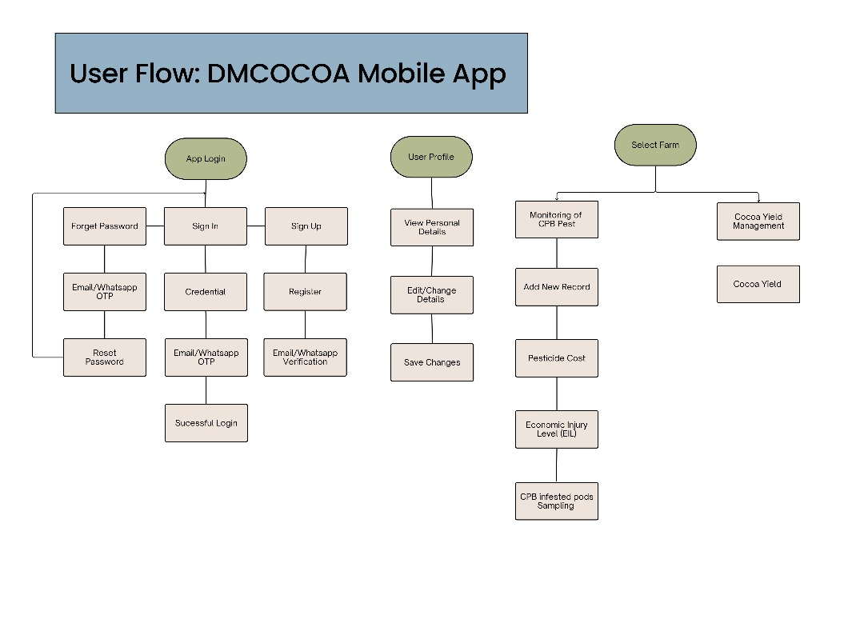

Detail version of User Flow

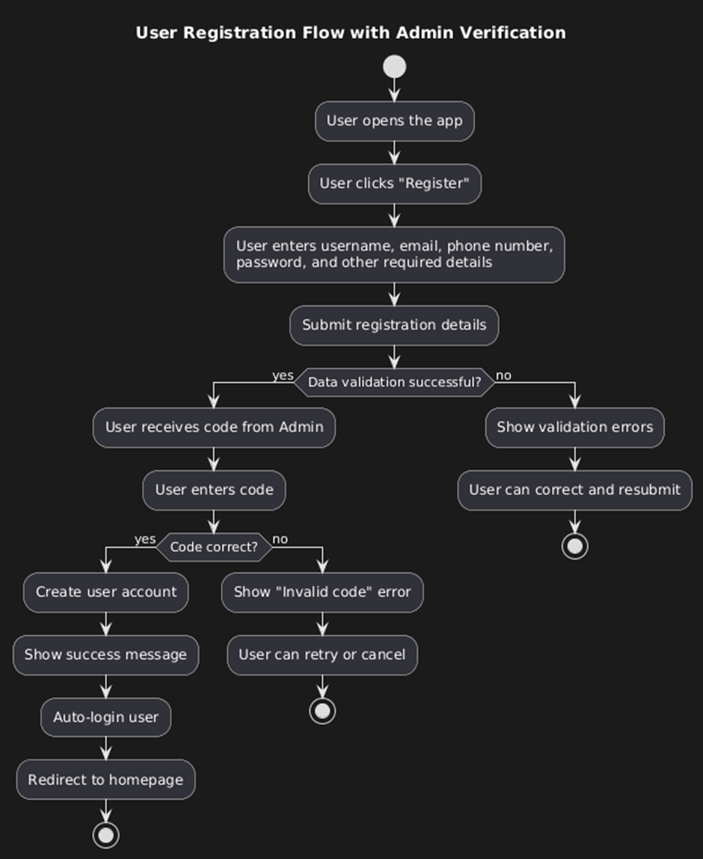 

 

 

## **2. Figma (UX UI Design)**

Completed (Y/N): Y

Evidence:

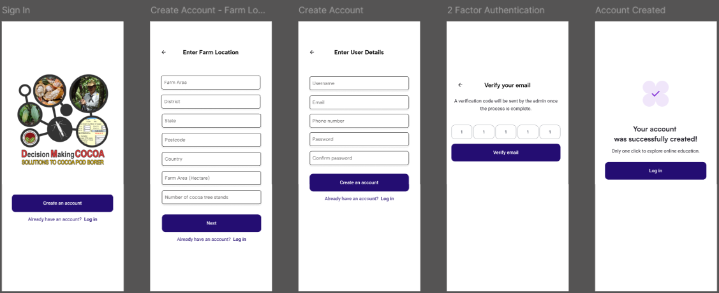

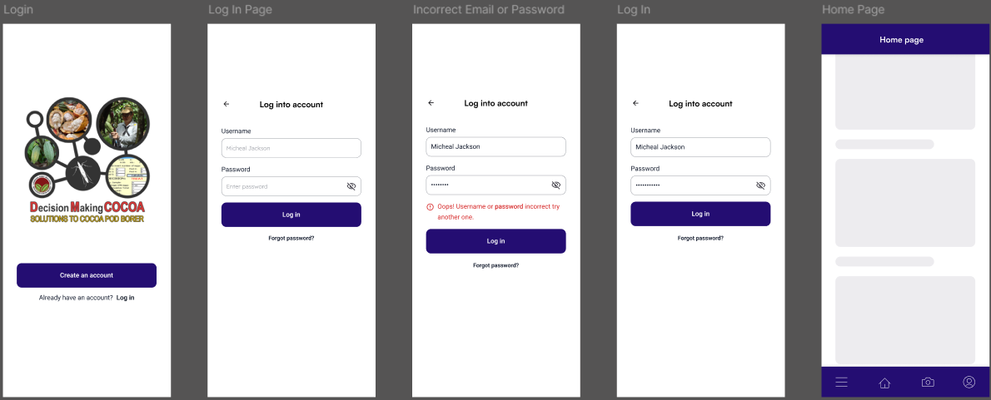

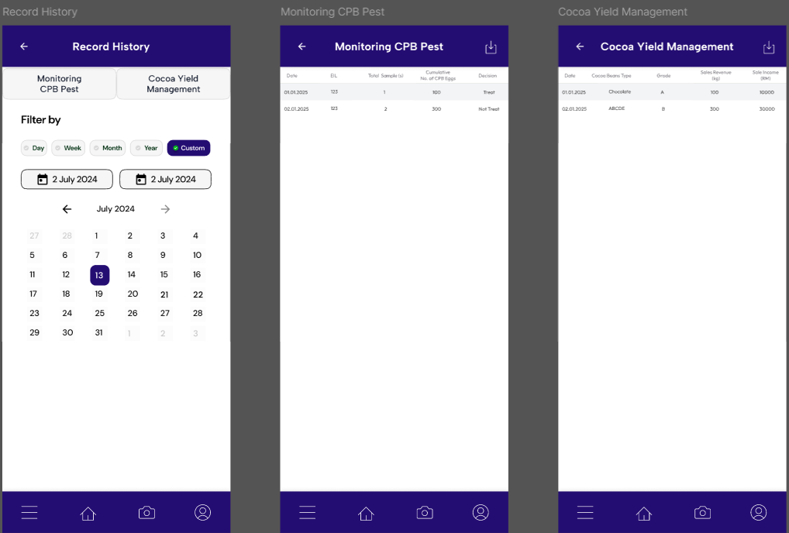



## **4. Build up Yolov8 Environment**

Completed (Y/N): Y

Evidence: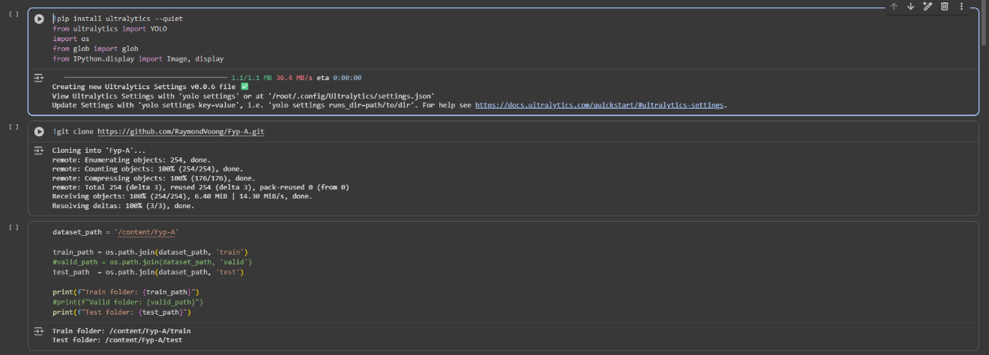

## **5. Data Annotation and augmentation**

Completed (Y/N): Y

Evidence:

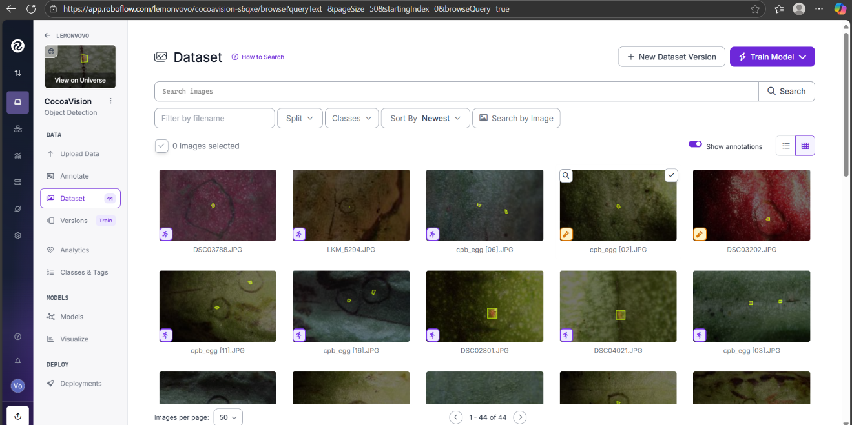

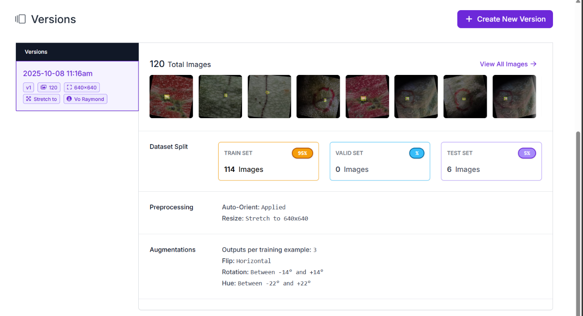

## **6. Model Training**

Completed (Y/N): Y

Evidence:

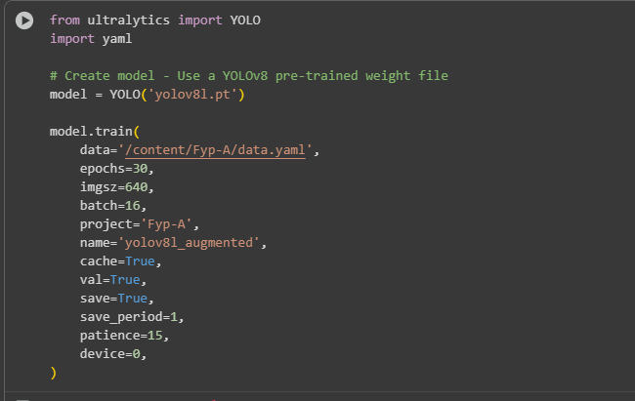

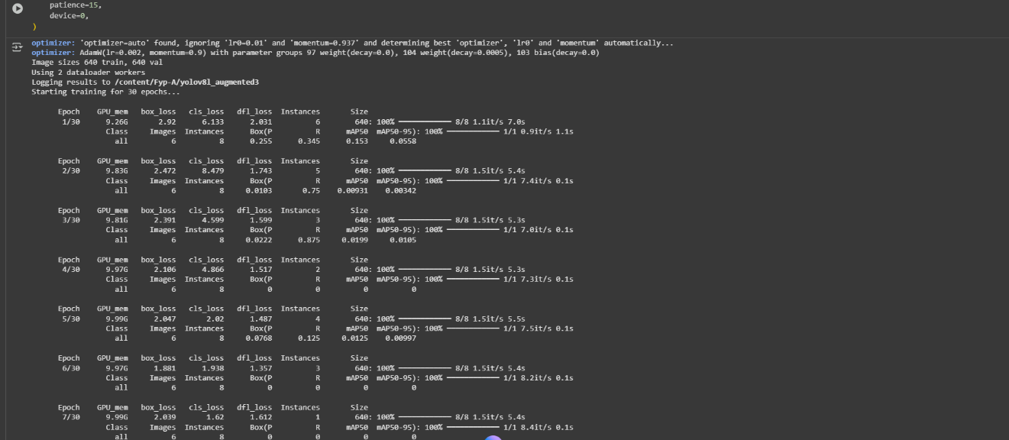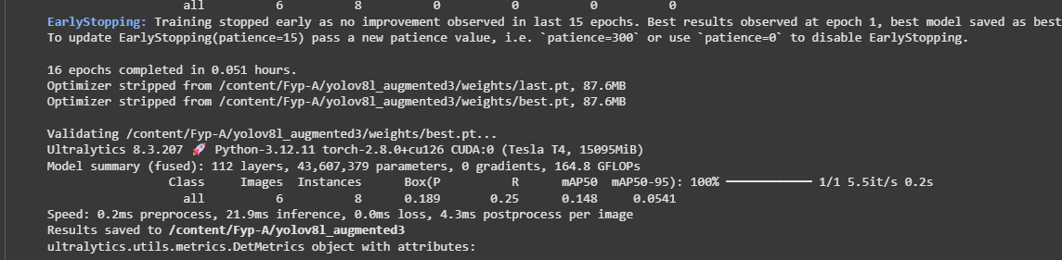

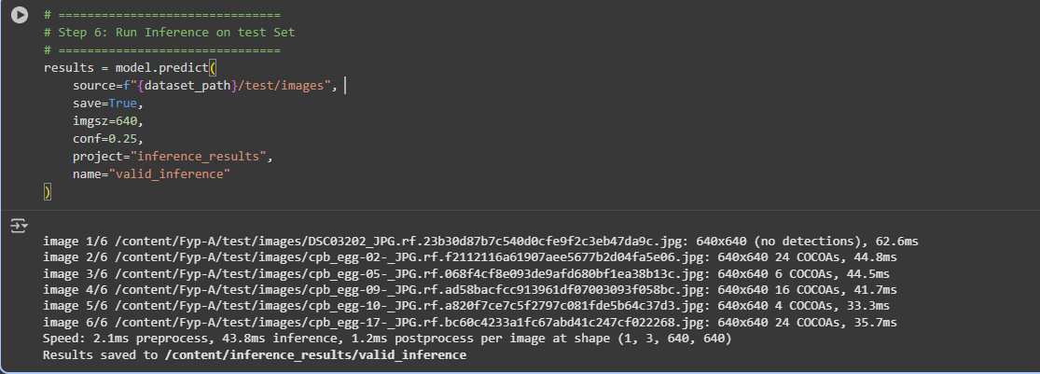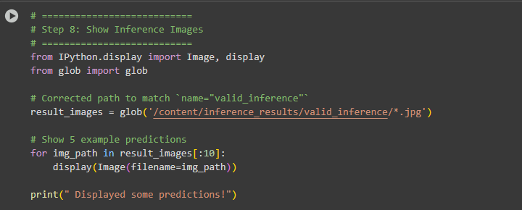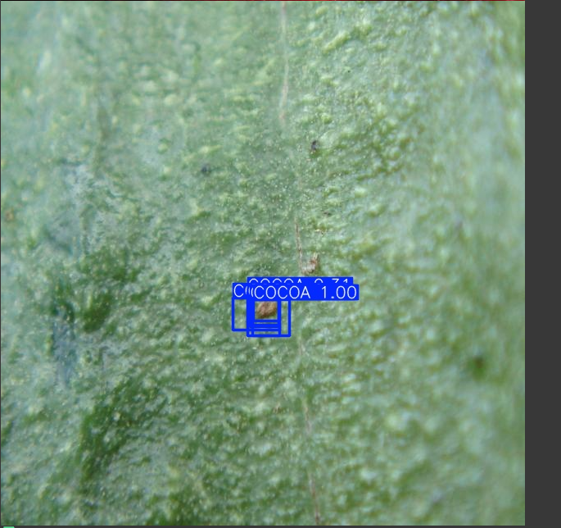

## **7. Trello Board**

Every team member’s task for this sprint is tracked with To Do, Doing, Testing and Done. The goal for using Trello Board is to track everyone’s work progress during the sprint and make sure the workload is progressively improved.

**Before Sprint 1:**

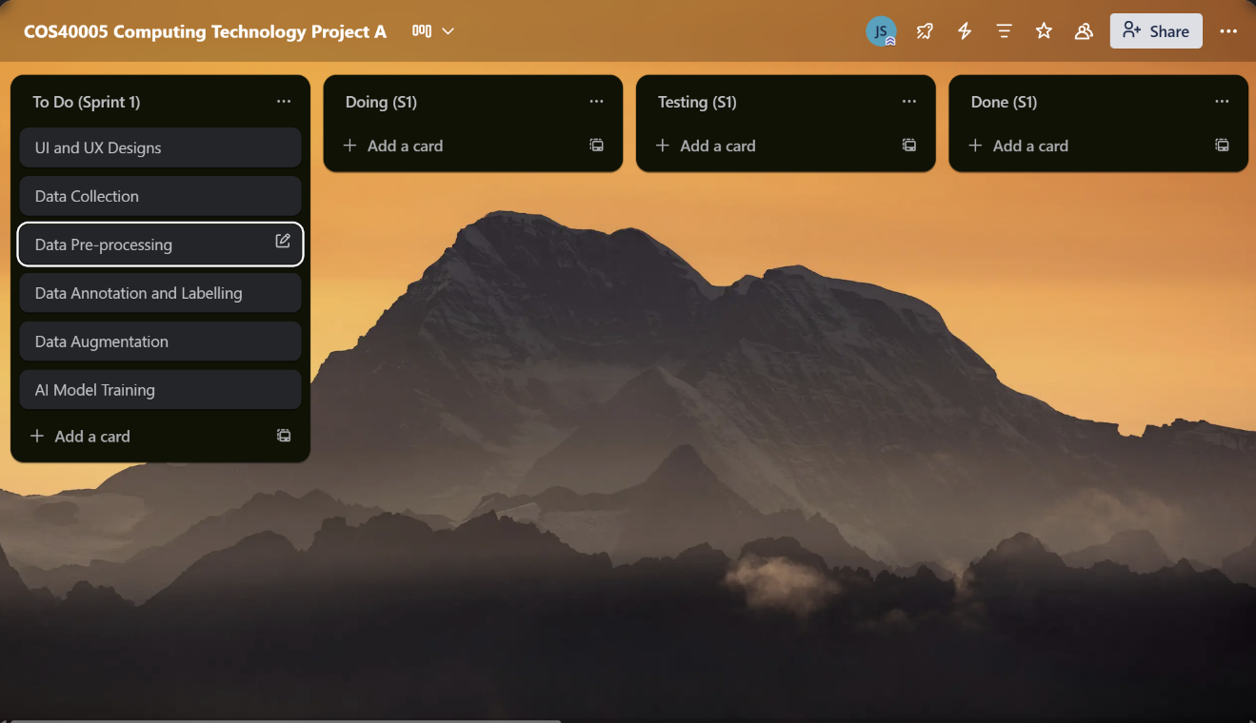

**First week of Sprint 1:**

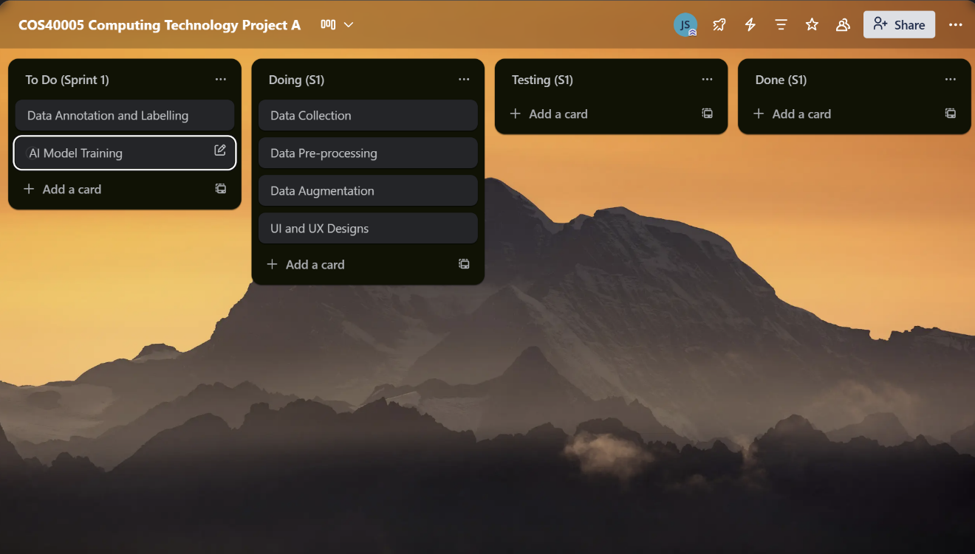

**Last week of Sprint 1:**

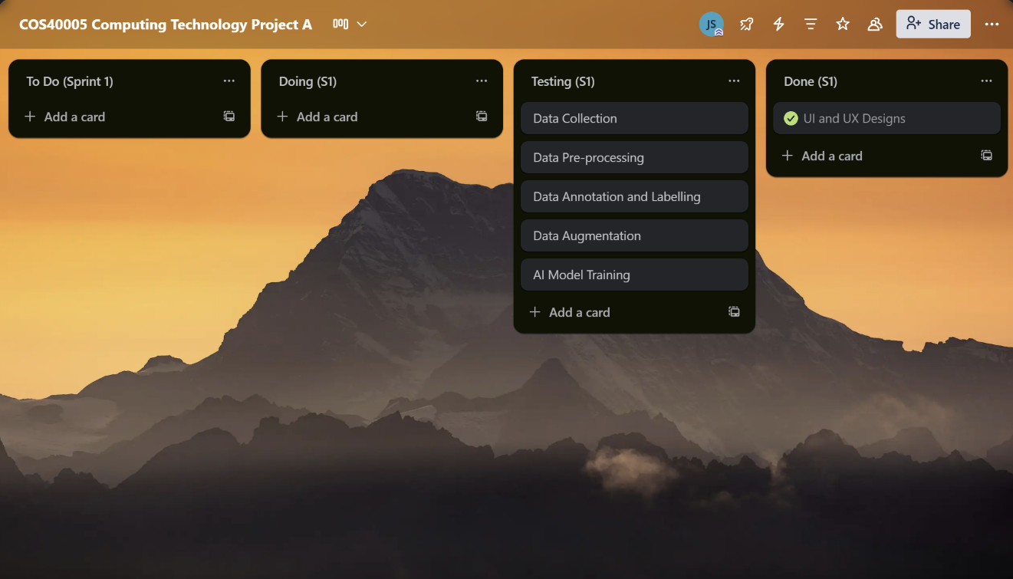

## **8. Gantt Chart**

The Gantt Chart is the overall Project timeline for the team when building this project, for sprint 1, the task that is being distributed will be the planning of the development phase which will be assigned during the next sprint, datelines and percentage of the progress will be monitored and recorded.

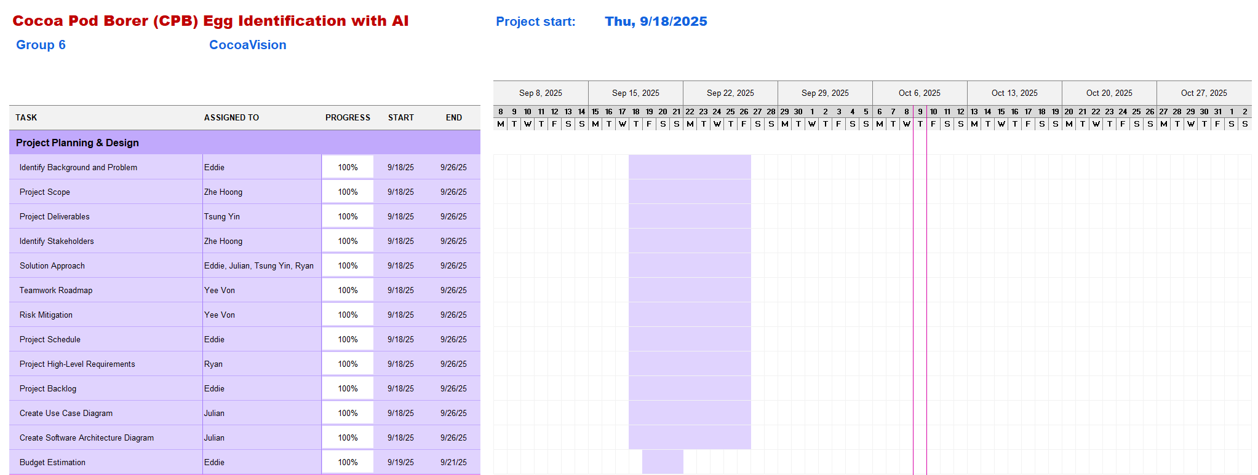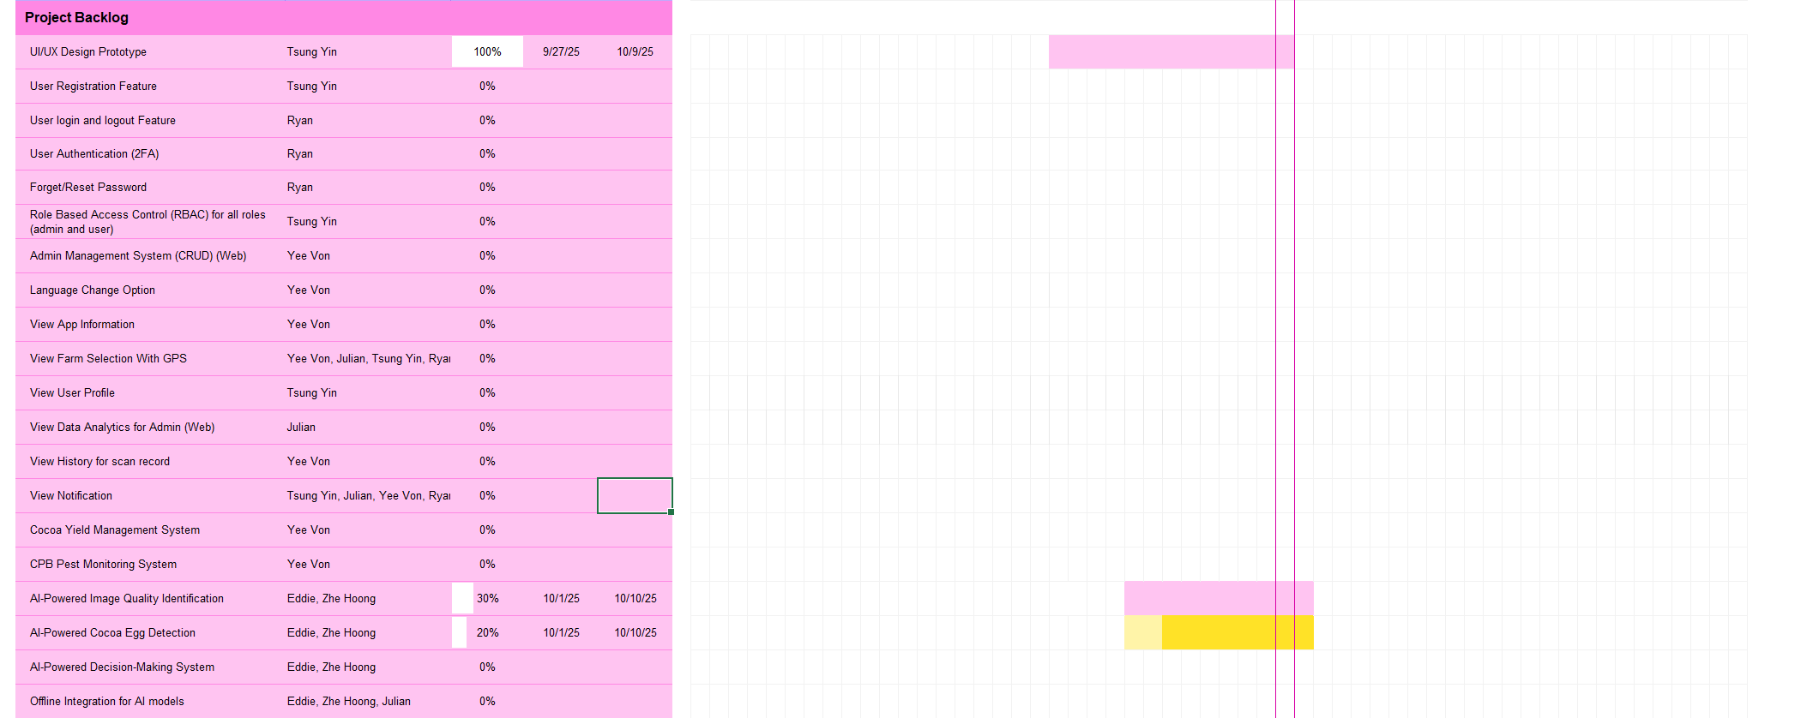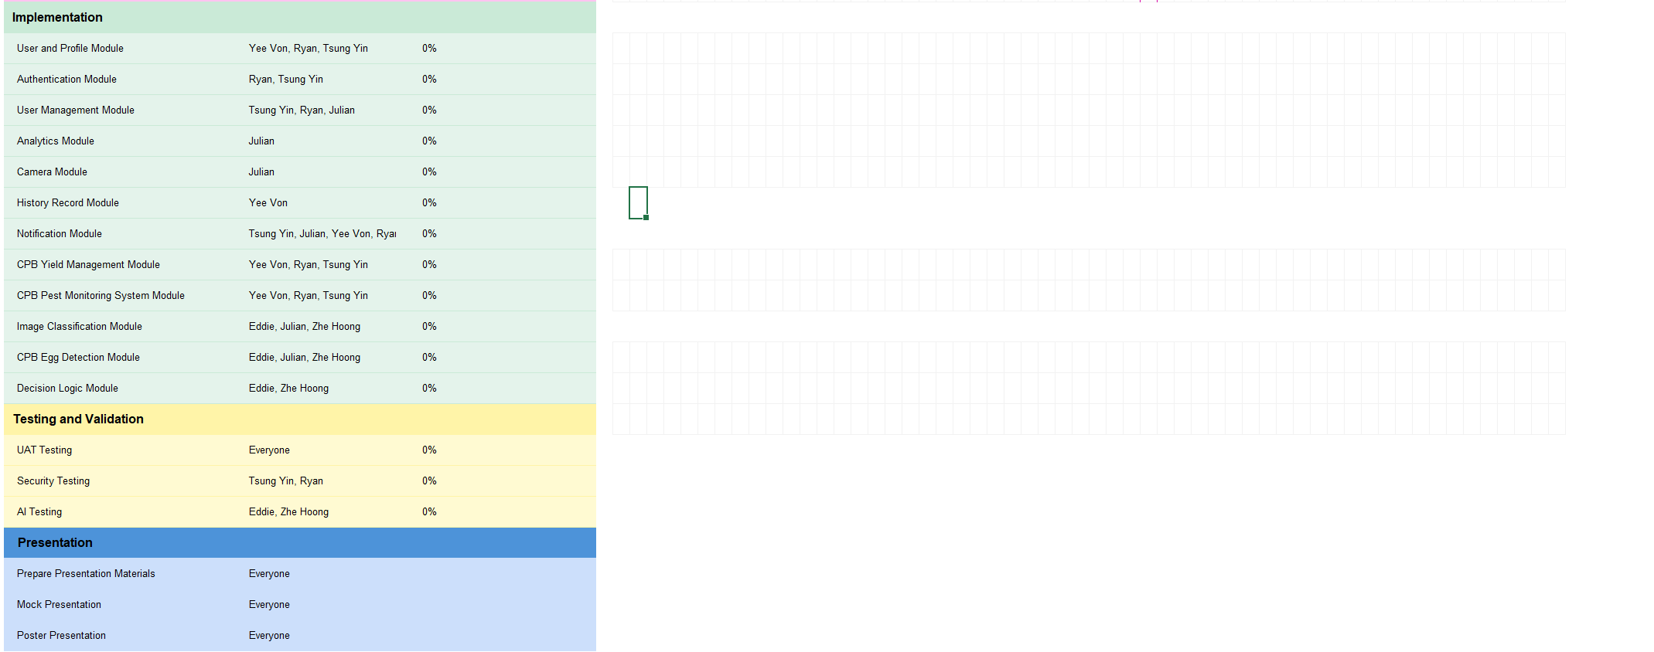

# **Sprint review**

**Description of Demonstration Session and Facilitation Process**

During Sprint 1, we conducted 3 meeting sessions with our client to discuss the project requirements, present our progress updates, and demonstrate our initial deliverables. The meetings were structured professionally, beginning with clear meeting agendas and objectives communicated in advance to the client one day. Each session included an introduction, a walkthrough of the completed deliverables, and an open discussion for feedback and clarification.

Throughout these sessions, the team maintained professional communication and active listening, ensuring that the client feedback and requirements were well understood. All members of the team participated in all the meeting sessions and answered the client questions effectively. Meeting notes were documented and shared with the client after each session to ensure all discussions were recorded.

**Feedback Received from the Client**

The client reviewed the deliverables and provided constructive feedback regarding functionality, design, and usability. The client confirmed that the deliverables were acceptable and met the sprint definition of done. However, they suggested that the user flow chart should include visual illustrations. The team acknowledged the feedback from them and planned to address the feedback in Sprint 2.

**Critical Analysis of Progress**

The team achieved significant progress during Sprint 1, including the successful completion of User Flow Chart Design, UI and UX Design, YoLov8 Environment Set Up, Data Annotation and Model Training. The sprint objectives were largely met within the planned timeline.

However, several challenges were encountered. The team received only limited data from the client, which resulted in the model training not meeting the expected accuracy. To address the challenges, the team proposed to receive additional data samples from the client before the next sprint to enhance the overall model robustness.

For the mobile application prototyping phase, on the other hand, the challenges we met were quite skewed to time-consumption, and difficulty to achieve equal agreement. We had many problems when coming up with the prototype as there were not much material and resources available for us to understand the overall functions and problems of the existing mobile application the client is using. We needed a few meetings until we could come to an agreement on certain operations and there would be more questions constantly appearing throughout the future. As different parties involved has their own opinion and decisions, it may create confusion for us as we are not too experienced, especially when everyone has different expectations. As every team member has their own tight schedule and heavy workload from other units, juggling between meetings and having to update the team’s work throughout each week is difficult, but it is believed that the team will manage.

Despite these issues, the team maintained effective teamwork, ensured consistent communication with the client and continued to make progress toward the overall project goals.

# **Retrospect (Critical review of the process)**

During Sprint 1, the team followed the planned sprint schedule, ensuring weekly meetings and timely task updates to track progress. Each member demonstrated accountability and commitment to their assigned tasks, contributing to the completion of deliverables.

**Strengths:**

The team’s major strengths during this sprint were effective teamwork, proactive communication and adaptability. All members were willing to help each other and share their own knowledge to solve the problems. The clear distribution of roles and responsibilities allowed the team to stay organized and meet the sprint deadline efficiently. Regular documentation also contributed to transparency.

**Challenges and Bottlenecks:**

Several challenges affected the sprint deliverables. The limited dataset provided by the client constrained the model training process, preventing the team from achieving desired accuracy. Additionally, the mobile application prototyping phase turned out to be challenging due to insufficient reference materials and limited understanding of the client’s existing system. Communication among multiple stakeholders including clients, supervisor and lecturer sometimes caused confusion as different stakeholders had their own opinions.

**Review of Team Code of Conduct**

Throughout the sprint, the team followed the team code of conduct on the team project plan, emphasizing professionalism, punctuality and respect during the meetings and discussions. All members contributed to a positive team environment by listening to each other’s opinions and giving honest feedback on the deliverables.

**Ethical Considerations**

In handling client data, the team is aware of ethical responsibilities. The cocoa pod image data used for model training was kept confidential and stored securely, ensuring compliance with the Australian Privacy Principles.

**Summary**

Overall, Sprint 1 was a productive sprint that laid a strong foundation for future development. While the team faced challenges with prototype clarity and image data availability, these experiences provided valuable lessons for improvement. Moving forward, the team aims to enhance stakeholder communication, obtain additional datasets earlier and continue strengthening teamwork to achieve a higher quality outcome in the next sprint.

# **Lessons learned (Critical review of SPRINT one experience and future plan)**

**Lesson Learned**

**Insufficient Dataset and Low-Quality Image Provided**

The client supplied a limited number of images, many of which lacked visible or clear examples of eggs on cocoa pods. This affected the quality of our initial model training.

**Enhancing Client Understanding with Visual Tools**

During the UI/UX design, we realized that not all clients are able to visualize the system conceptually. Therefore, using visual tools such as user flow diagrams and Figma prototypes proved highly effective in conveying our design ideas more clearly. This method also minimizes time spent on clarifications and revisions.

**Managing Client Queries**

Several members were working on the mobile app development; we often had many questions to ask the client. However, these questions were stored across different devices, making it difficult to access them efficiently during meetings. As a result, some questions were missing or took time to locate. To improve this, we plan to compile all questions in a shared document or centralized platform to ensure smoother communication in future meetings.

**Future Plan**

**Being Very Clear with the Data Requirement and Do Some Research on dealing with insufficient datasets**

Conduct a dedicated meeting with clients to request specific data collection guide, including sample image references and instructions to ensure consistency and usability of the data set.

Do more research on the way to train the model with insufficient dataset (Few Shot Learning)

# Appendix

